|  |
| --- |
| **PT. BERLIAN SISTEM INFORMASI** |
| **Operating Lease – Unit/Vehicle Management Process** |
| **USER MANUAL GUIDE** |
|  |
| **VERSION 1.1** |
| **7/1/2016** |

|  |
| --- |
| All material contained in this manual including text, graphics, icons and images contain proprietary and confidential information of PT. Berlian Sistem Informasi and are protected by international intellectual property and other laws. The compilation of all text, graphics, icons and images in this Manual is the exclusive property of PT. Berlian Sistem Informasi. No modification, rental, lease, sale, transmission, distribution, reposting or creation or derivate works based on the material in this Manual is allowed, unless with the express permission of PT. Berlian Sistem Informasi. |

# REVISION HISTORY

|  |  |  |  |
| --- | --- | --- | --- |
| **Date** | **Revision** | **Description** | **Author** |
| 3/21/2016 | 0.0 | Initial Document | Sabilla Pravita Larassati |
| 3/29/2016 | 0.1 | Update Capture | AR. Anggun Cahyaningtyas |
| 5/17/2016 | 0.2 | Update Capture | AR. Anggun Cahyaningtyas |
| 5/28/2016 | 1.0 | 1st Baseline | Grand Zah Putra |
| 7/1/2016 | 1.1 | Update Document after Training | Sabilla Pravita Larassati |

# TABLE OF CONTENT

REVISION HISTORY 2

TABLE OF CONTENT 3

UNIT MANAGEMENT MODULE 5

1. BAST DELIVERY AND RECEIVING 5

1.1. Unit Preparation Monitoring 5

1.2. Update Unit Preparation 8

1.3. Create BAST customer and BAST supplier 11

1.4. Edit a Draft or Revised Document of BAST 15

1.5. BAST supplier and BAST customer Detail 18

1.6. Print BAST Supplier and Print BAST Customer 21

1.7. Print BAST Report 24

2. BAST REPLACEMENT 25

2.1 Monitoring OPL unit and Replacement Unit 26

2.2 View History Replacement Unit Usage 29

2.3 Print BAST replacement unit report 30

2.4 Print BAST OPL unit report 30

2.5 Register Replacement Unit 31

2.6 Create BAST replacement unit and OPL unit 35

2.7 Edit BAST replacement unit and OPL unit 39

2.8 View BAST replacement unit and OPL unit 42

2.9 Print BAST replacement form 45

2.10 Print memo replacement report (Special Case) 47

3. BAST REPLACEMENT APPROVAL 50

4. MONITORING AND PRINT DOCUMENT COMPLEMENT UNIT 54

4.1. View list of expired and pending document 54

4.2. Update progress expired document 55

4.3. Print monitoring unit report 55

# UNIT MANAGEMENT MODULE

Operating Lease Support System includes Procurement Process, **Unit/Vehicle Management Process**, Unit/Vehicle Maintenance Process, and Collection Process. All features will be described in the subsequent sections. The Unit Management menu of Operating Lease Support System serves as the continuation of Procurement Process. With the unit management menu, you will be able to monitor unit preparation for each unit requested with different supplier, and monitor replacement unit if customer request for replacement registration.

Additionally you can enter new record, make changes, and inspect a detail record, and also filter specific records based on columns by writing a keyword on the search field. The features and data contained in your Operating Lease Support System menu are limited by your security and data authorization settings so you may not be able to access all features.

# BAST DELIVERY AND RECEIVING

Item that has been processed at Purchase Order process, will automatically listed in Unit Preparation monitoring menu. Unit preparation menu will facilitate user to monitor every item requested for each supplier. User can check which item that haven’t yet been processed, as well as items that already near the delivery due date. If the unit has been completely prepared, user can manage BAST for each item delivered, either from the supplier or to customer.

Only authorized user have access to all records in order to keep them up to date. Unit preparation monitoring page provides following functions:

1. Check unit preparation progress based on PO remaining delivery time.
2. Filter and sort a data that appears on the list. To do this function user can do as follows:
   1. Click  to sort a record ascending or descending.
   2. Filter a numbers of records by selecting.
   3. Filter records by input keywords at.
3. View history detail for each item listed, by clicking View History button.
4. Modify unit preparation progress; keep them up-to-date.
5. Print unit preparation monitoring report.

## Unit Preparation Monitoring

At the beginning, user can open Unit Preparation Monitoring by clicking the “Unit Preparation Monitoring” on the Unit Management menu. Once clicked the menu, system will display the Unit Preparation Monitoring page. When opening the page it may look as following:

1. Navigate to **Unit Management** menu and click “**Monitoring Unit Preparation**”.

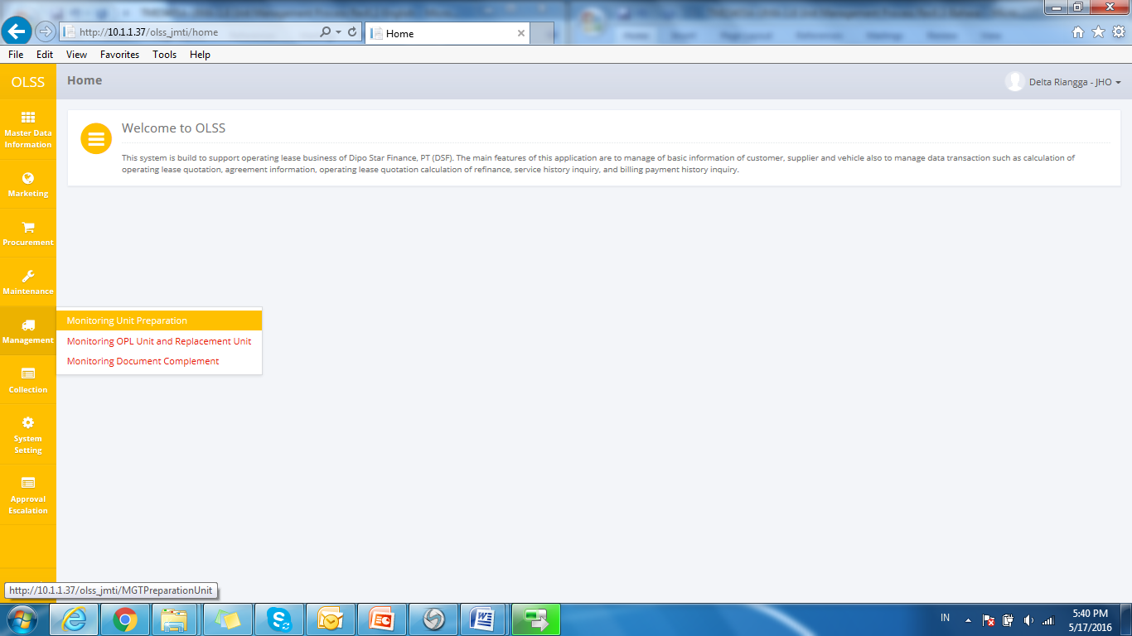

Screen 1: Unit Management Menu

1. System will show **Monitoring Unit Preparation** that consisted of approved PO number. The main page of Unit Preparation Monitoring is shown below:

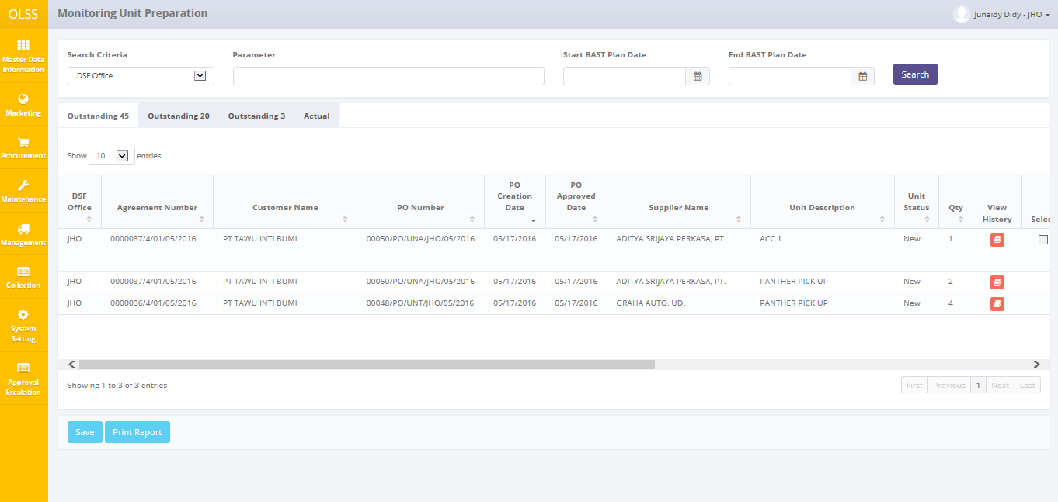

Screen 2: List of Purchase order Information Inquiry

On **Monitoring Unit Preparation** screen, there are 4 tabs in total, which are:

* 1. Outstanding 45, display PO number with remaining delivery days same or less than 45 days.
  2. Outstanding 20, display PO number with remaining delivery days same or less than 20 days.
  3. Outstanding 3, display PO number with remaining delivery days same or less than 3 days.
  4. Actual, display PO number with completed BAST.

There are 7 buttons that will be displayed on tab outstanding 45, 20 and 3, which are:

* 1. View History: click the button to check Unit preparation Progress history.

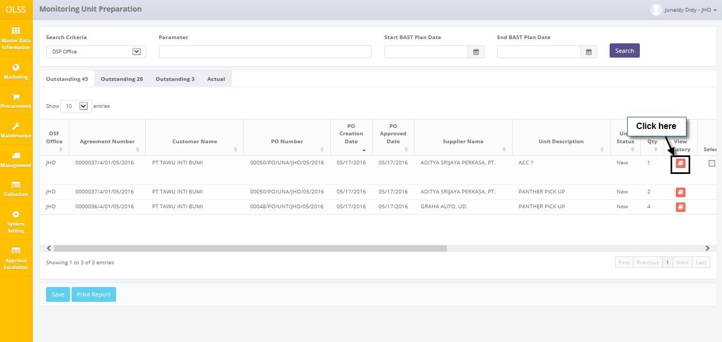

**Screen 3: Navigate to check Unit Preparation Progress history**

* 1. Create BAST : click to create BAST delivery and receiving. The button will only active if supplier has complete unit preparation.
  2. Edit BAST : click to modify BAST delivery and receiving. The button will only active if BAST has been created and saved as draft.
  3. Print BAST Supplier : click to print BAST document from supplier to DSF.
  4. Print BAST Customer : click to print BAST document from DSF to customer.
  5.  : click the button to update selected PO number.
  6. : click the button to print report purchase order list.

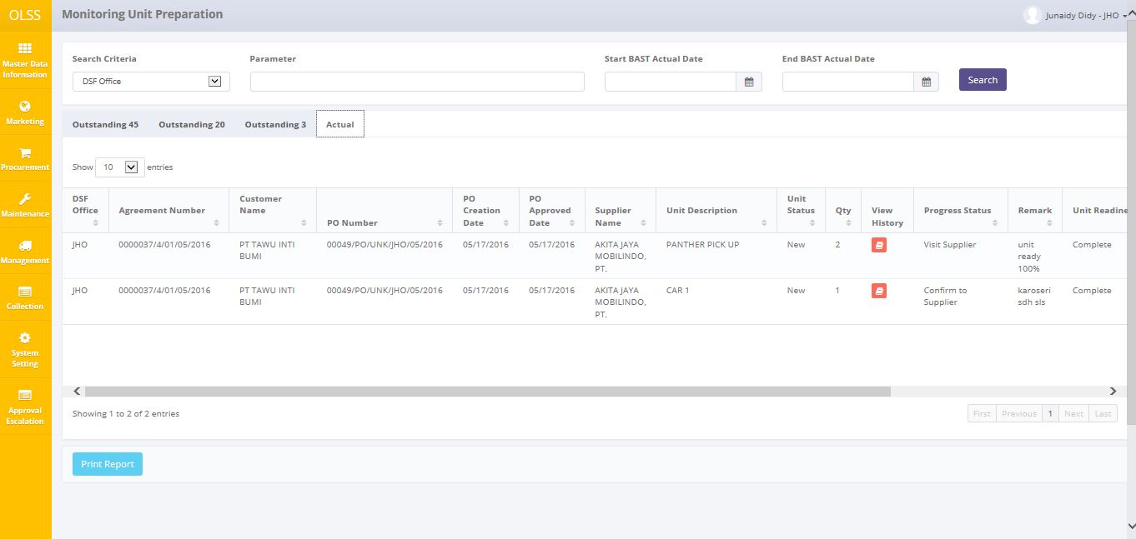

**Screen 4: Screen List of Unit Preparation on Tab Actual**

Tab Actual have different buttons than tab Outstanding, the buttons are:

1. View Details : click the button to view detail of completed unit preparation.
2. : click the button to print report purchase order list.

## Update Unit Preparation

To update unit preparation, first navigate to outstanding tab: 45, 20, or 3. Once the information is showed, user can change or fill information. See the picture below:

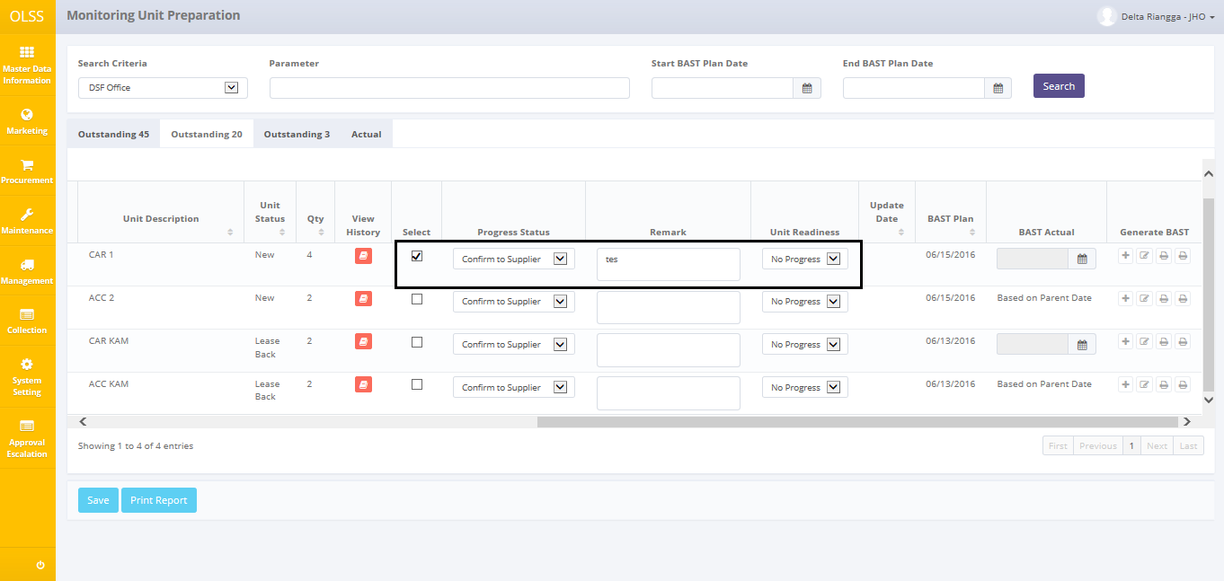

Screen 5: Screen Update Unit Preparation

Fill information by following description:

1. Select button: select field to notify that PO number will be updated.
2. Progress status: Select Confirm to Supplier or Visit Supplier.
3. Remark: input remark based on unit preparation progress, example: 50% unit complete
4. Unit readiness: select Complete, In progress, or no progress (default is no progress)
5. Update date: automatically show document updated date.

If data already entered on the screen, check on the checklist field to give mark that the PO numbers want to be updated. User can select more than one PO number to update in batch. Before clicking **save** button, please pay attention to several things:

1. PO numbers only allowed to be updated once a day. After PO number updated, fields will be disabled.

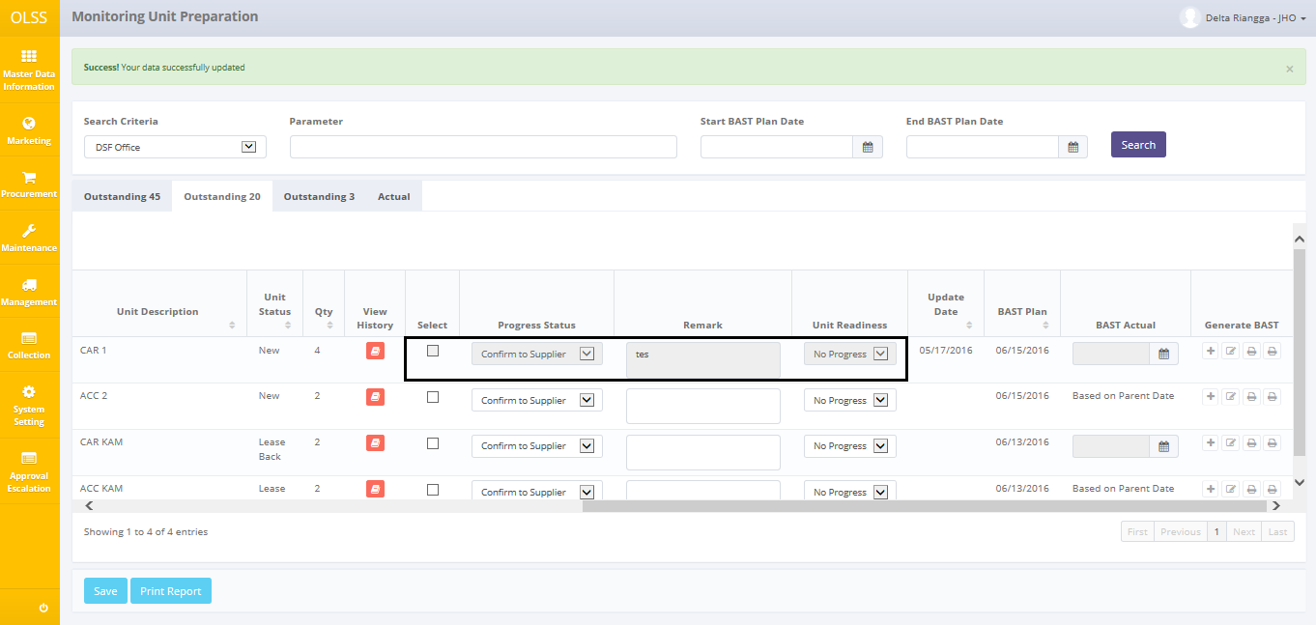

Screen 6: PO Number after updated

1. Some fields are mandatory and if user leaves it as blanks, system will show error message upon saving.

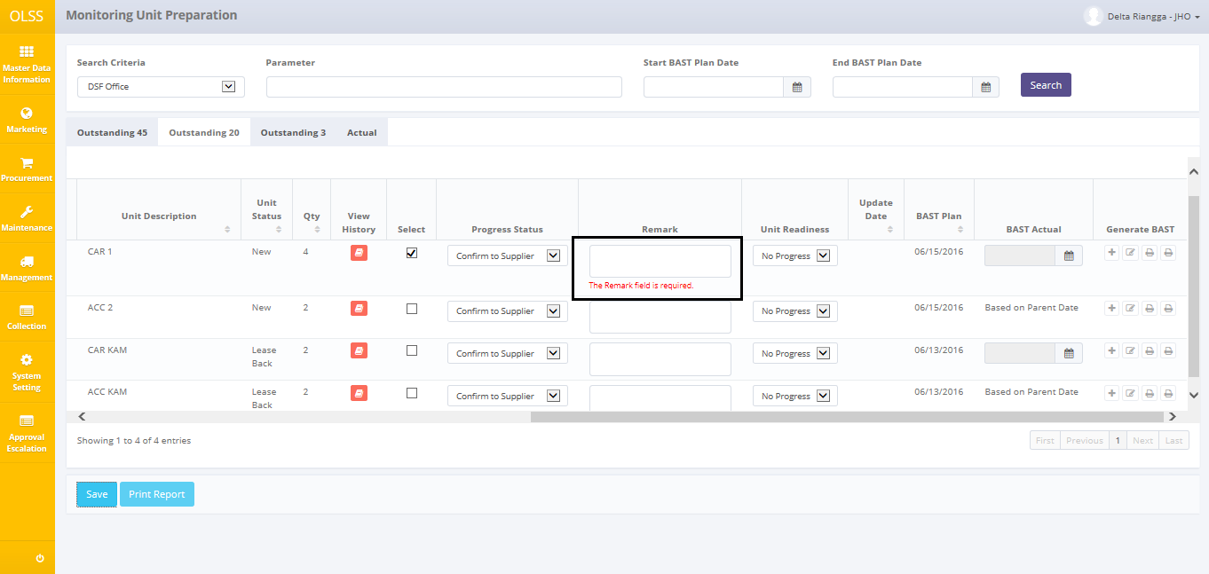

Screen 7: Error Mandatory Field after Save

1. System will check if agreement number has multiple suppliers and multiple items. If one supplier already completed the preparation, system will wait until the other supplier is completed also. If user set one supplier as completed, while the other supplier still on progress, then system will show error message.



Screen 8: Error Notification Not Completed

After clicking **save** button, system will show confirmation pop-up dialog. Click **yes** to continue.

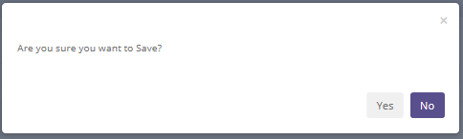

Screen 9: Screen Pop up Confirmation

System will notified if it success or failed to update the data.



Screen 10: Success notification after Save

## Create BAST customer and BAST supplier

BAST unit delivery and receiving can be created after supplier has completed the unit preparation. By system, create BAST button will enabled after unit preparation has been set as completed. BAST is created as many as unit ordered.

If user wants to create new BAST customer and BAST supplier, please follow procedures shown below:

1. Click **Create** button on selected unit.

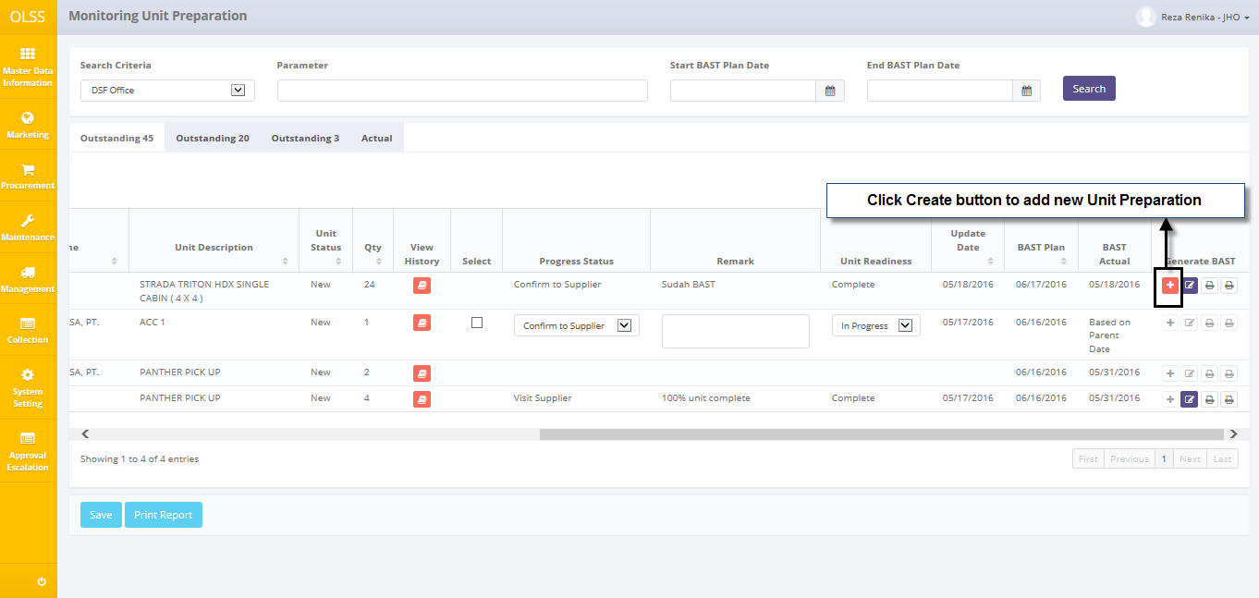

**Screen 11: Navigate to Create BAST**

1. System will display Create BAST screen.

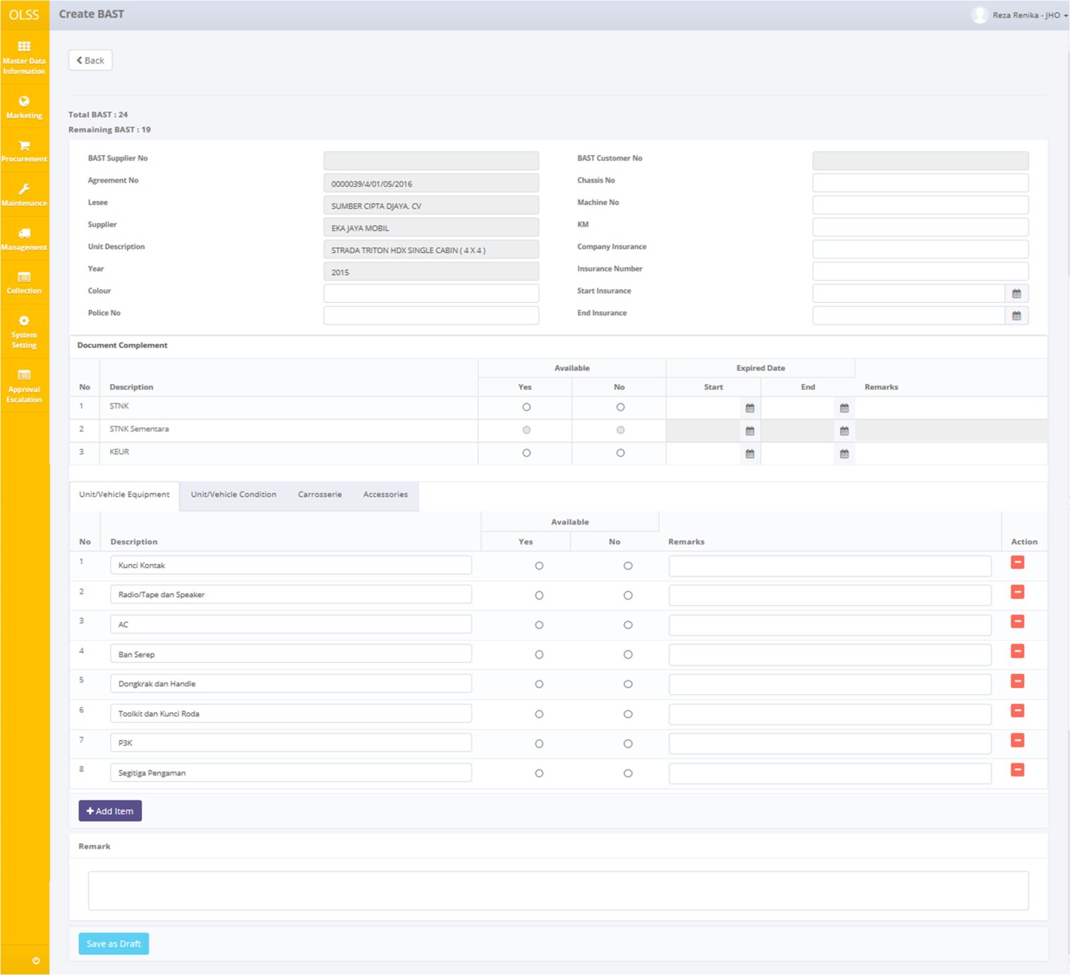

**Screen 12: Screen Create BAST**

Once Create BAST screen opened, there are 2 buttons displayed:

1. Back : click the button to go to previous screen: unit preparation monitoring.
2. Save as Draft: click the button to save document temporary as draft.

To start creating BAST, please input following fields with necessary information:

1. BAST information

* Color: input color.
* Police No: input unit police number
* Chassis No: input unit chassis number
* Machine No: input unit machine number
* KM: input how many KM units will be driven
* Company Insurance: input Company Insurance name
* Insurance Number: input Company Insurance number
* Start Insurance: select start insurance date
* End Insurance: select End insurance date

1. Document Complement:

* Available: select yes or no
* Expired Date: select start date and end data
* Remark: input remarks

1. Tab Unit/Vehicle equipment, unit/vehicle condition, carrosseries, and accessories:

* Description: input equipment description
* Available: select yes or no
* Remarks: input remarks
* Add item button: click to add row for Unit/Vehicle equipment, unit/vehicle condition, carrosseries, or accessories.
* Remove button (Action column): click to remove row for Unit/Vehicle equipment, unit/vehicle condition, carrosseries, and accessories

User can save data on the system by clicking Save as Draft. There are several mandatory fields that should be inputted before clicking save as draft. If user leaves it blanks or wrong, system will notified it after clicking Save as Draft. Clicking Save as Draft button will display confirmation pop-up dialog will show up. Click yes to continue.

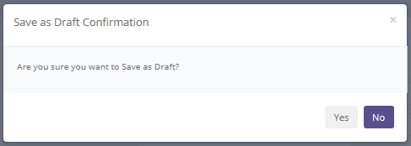

**Screen 13: Pop up Confirmation to Save as Draft**

If document processed is not refinance type, system will show 2 notifications upon saving, BAST supplier and BAST customer.



**Screen 14: Success notification after Save as Draft (Not Refinance Type)**

If document processed is refinance type, system will show only 1 notification upon saving: BAST customer.



**Screen 15: Success notification after Save as Draft (Refinance Type)**

## Edit a Draft or Revised Document of BAST

To edit BAST document, navigate to the Unit Preparation and click Edit button on the right side of selected agreement. Edit button only enabled if BAST already created and saved as draft. Document only able to be edited by the same user who create the document.

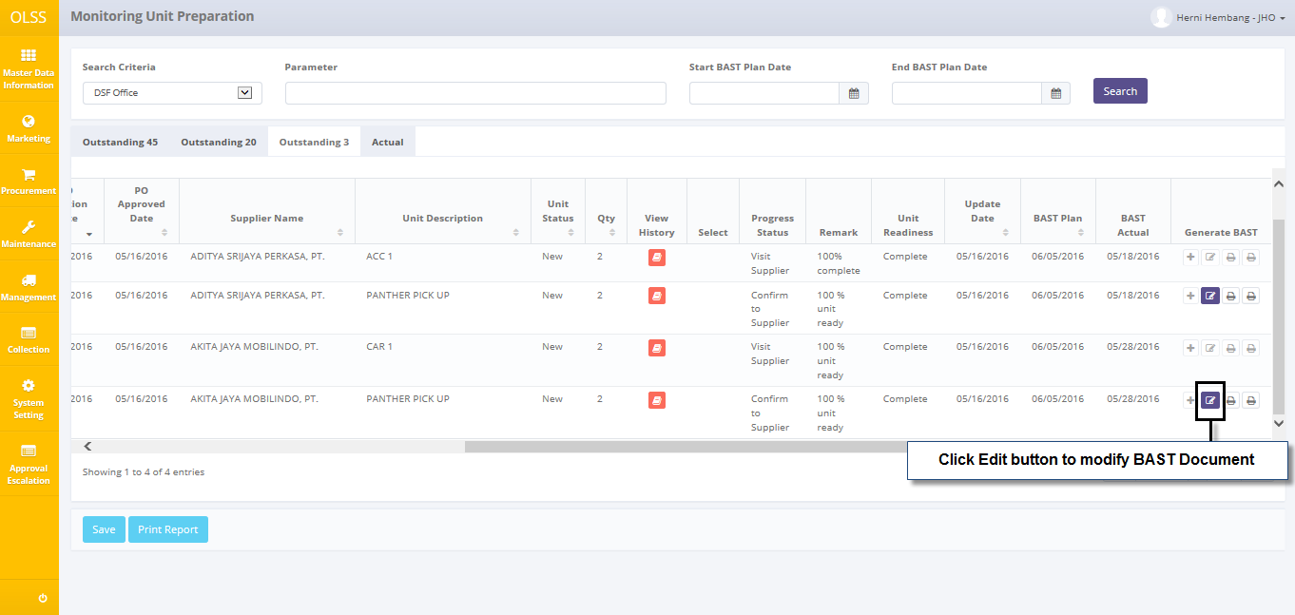

Screen 16: Navigate to Edit BAST

The screen below is shown after the Edit button is clicked.

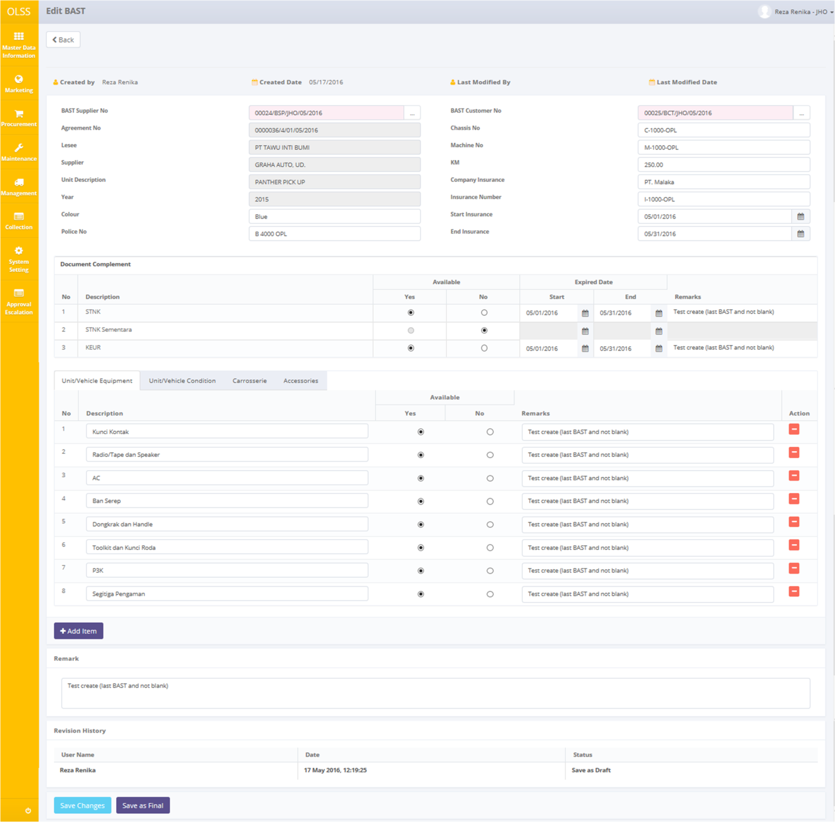

Screen 17: Screen of Edit BAST

There are three buttons that will be displayed on the screen as follows:

1. , on the top-left corner of the screen.
2. , on the bottom-left corner of the screen.
3. , on the bottom-left corner of the screen. Save as final document will move to actual tab

There are information fields on top of the screen, consist of the user information that created the document and had make changes to the records. To edit data, select BAST Supplier Number, select BAST customer number, and change necessary information. If data already changed on the screen, user can save a data on the system by clicking **Save Changes** button, or **Save as Final** button. Ensure that you actually want to **Save as Final** a record, because the records can’t be updated after submitted by user.

There are mandatory fields marked with red background field that should be inputted and it can’t leave as blanks. If you leave them blanks, system will notified it after you clicking **Save Changes** or **Submit** button.

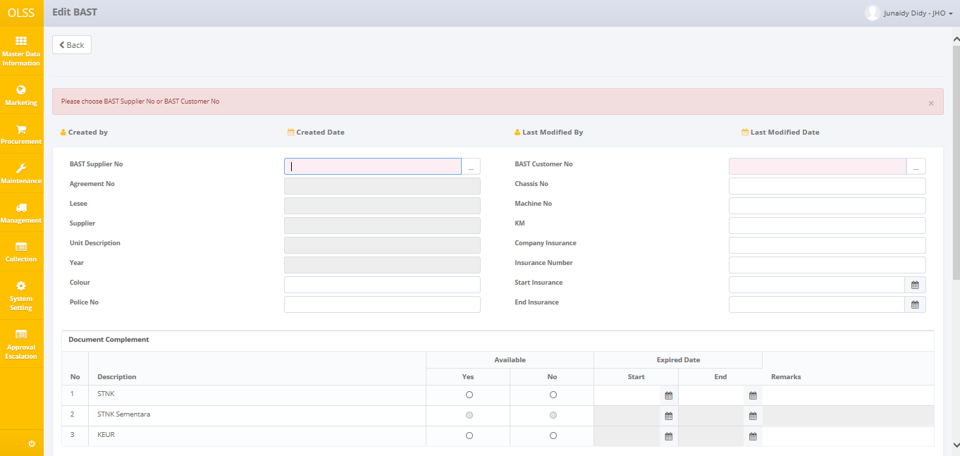

Screen 18: Error notification after Save Changes/Save as Final

After clicking **Save Changes** or **Save as Final** button, confirmation pop-up dialog will show up. Click yes to save document.

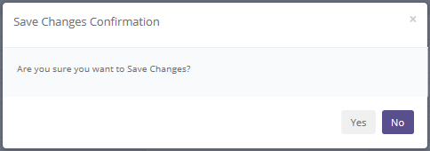

Screen 19: Pop up Confirmation after Save Changes

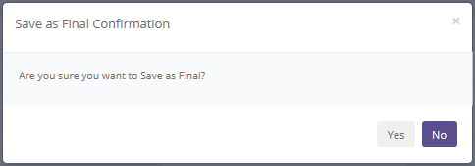

Screen 20: Pop up Confirmation after Save as Final

System will notified if it success or failed to save changes or save as final a data.



Screen 21: Success notification after Save Changes



Screen 22: Success notification after Save as Final

## BAST supplier and BAST customer Detail

To view the records, you can select a record from the Unit Preparation Monitoring page. Navigate to tab Actual, and then click the view details button, on selected agreement.

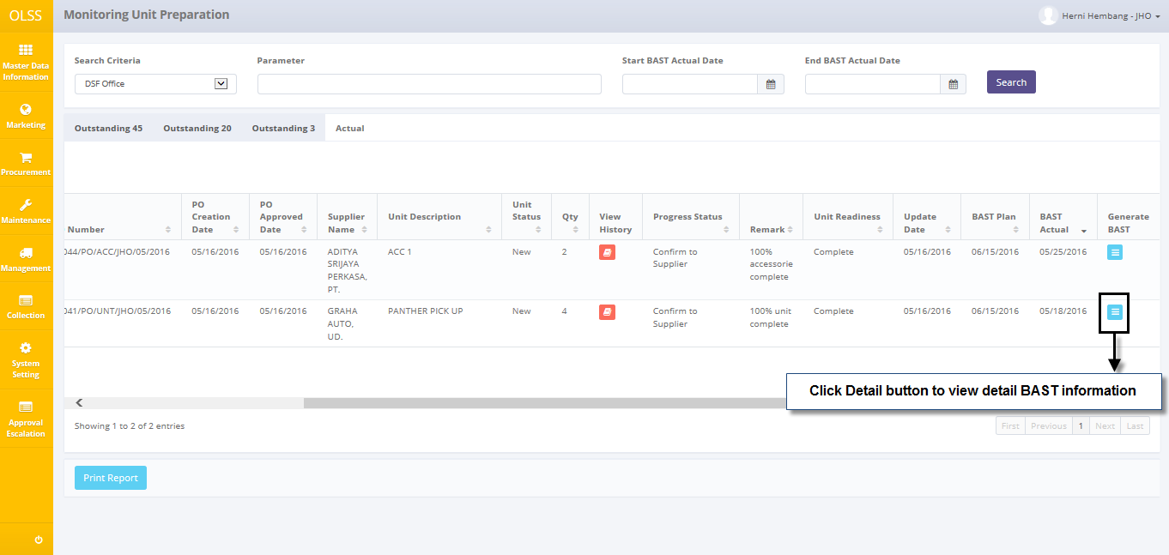

Screen 23: Navigate to View Detail BAST

System will show BAST Receiving Delivery pop-up screen shown below:

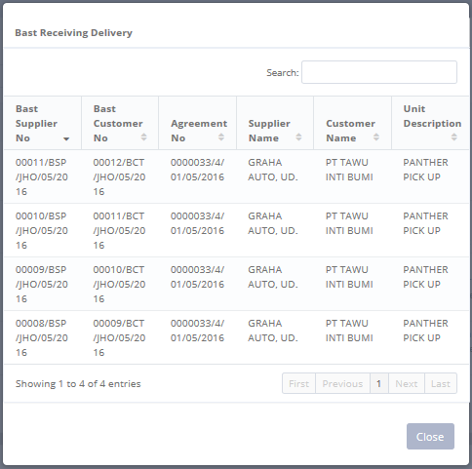

Screen 24: BAST Receiving Delivery Pop Up Screen

System will show View BAST screen shown below:

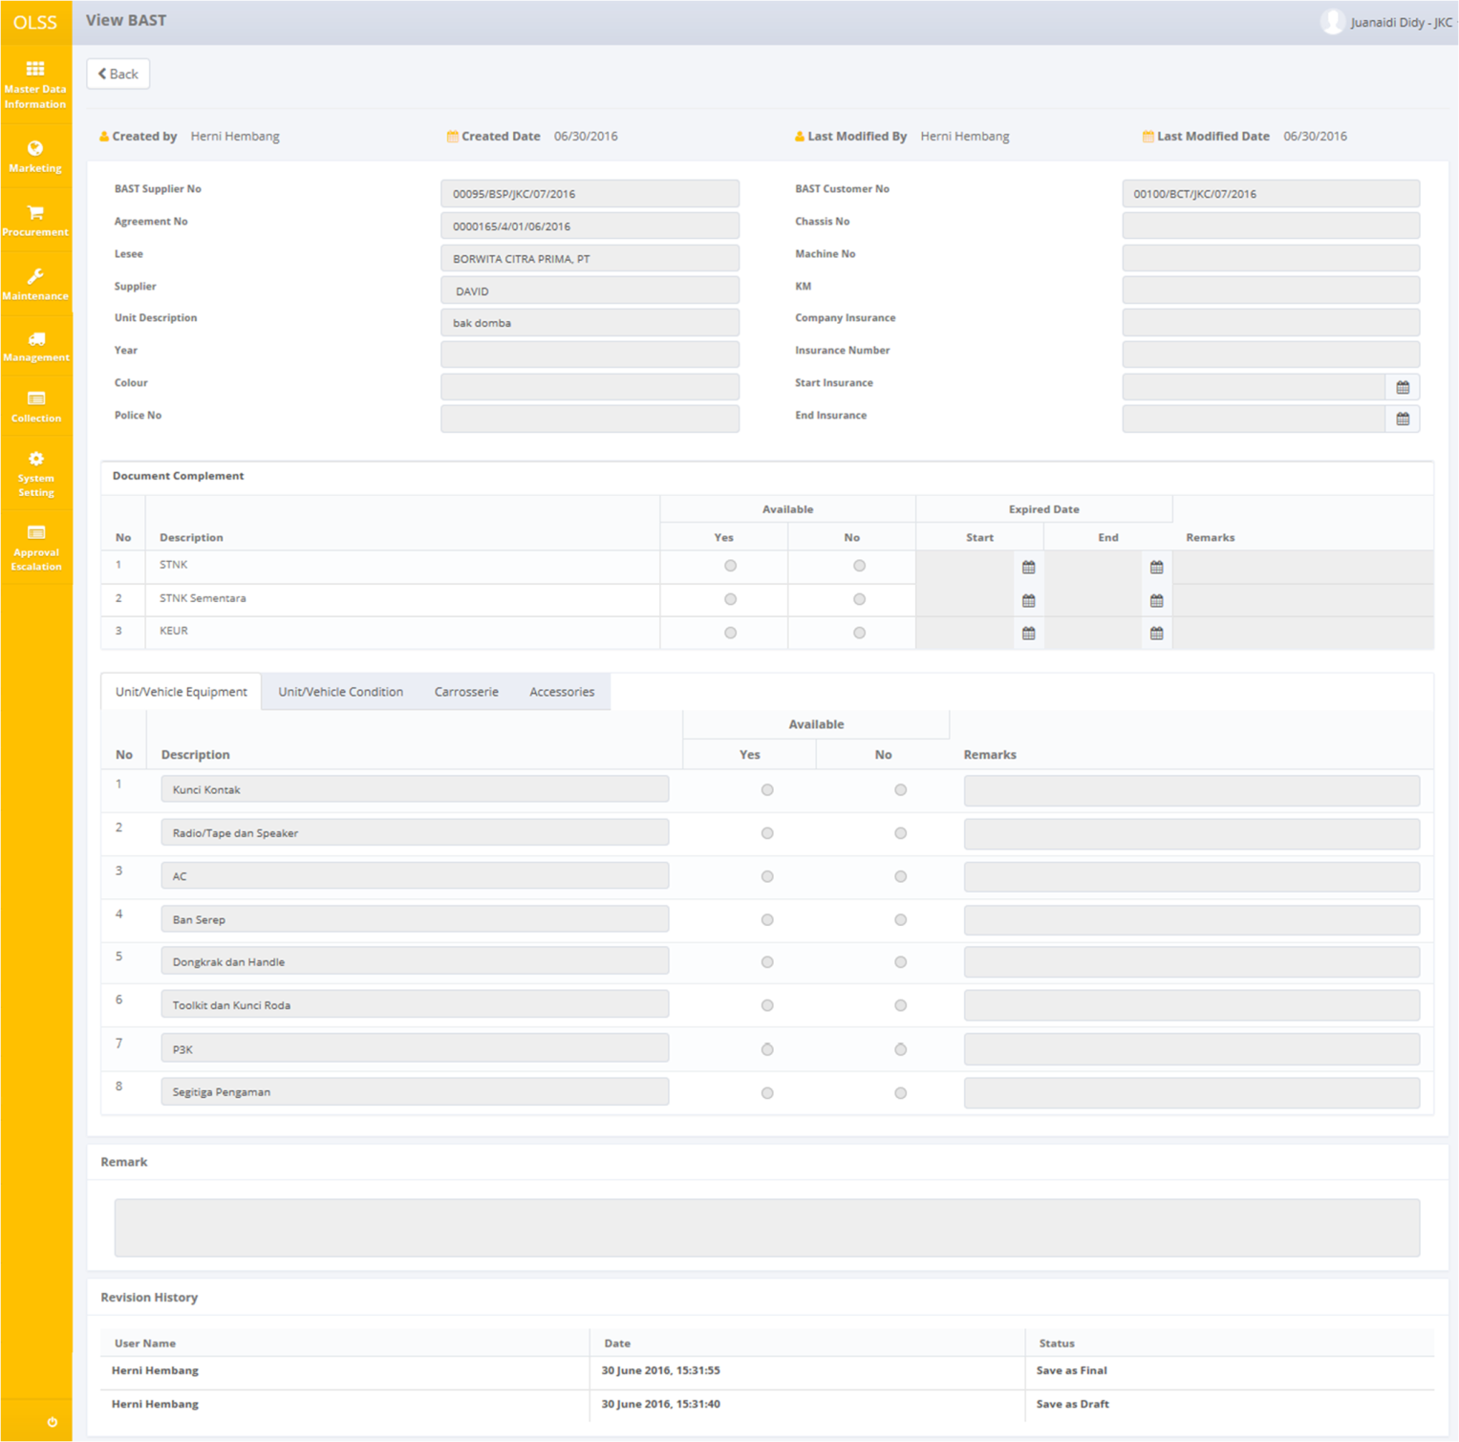

Screen 25: Screen View Detail BAST

Here you can see the detail information related with BAST supplier and BAST customer. User can check the records but the records cannot be clicked or edited. Click  on top of the screen to go back to previous screen.

## Print BAST Supplier and Print BAST Customer

User can print BAST supplier to DSF and BAST DSF to customer by clicking the button  (right and left) on selected agreement as shown below:

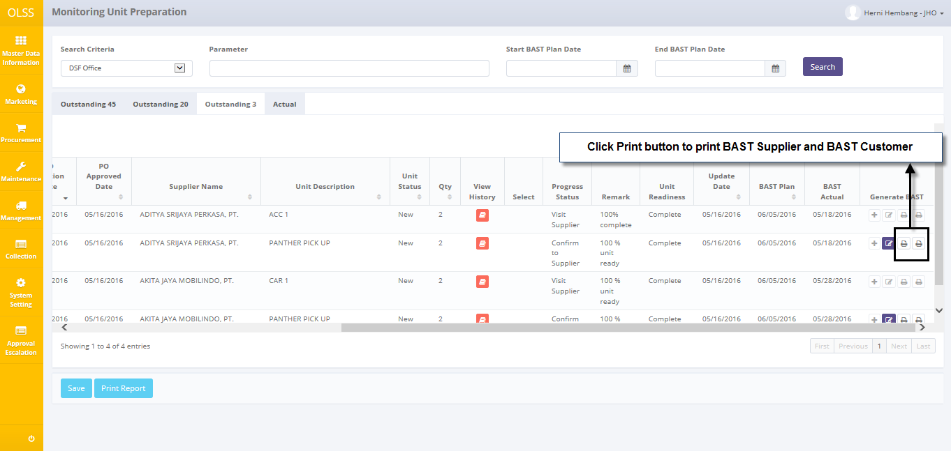

Screen 26: Navigate to Print BAST Supplier and BAST Customer

Select to print All BAST Document, or select document BAST that will be printed by input page number. System will navigate to BAST form print preview. User can print document as hardcopy, or save document as PDF or Ms. Excel.

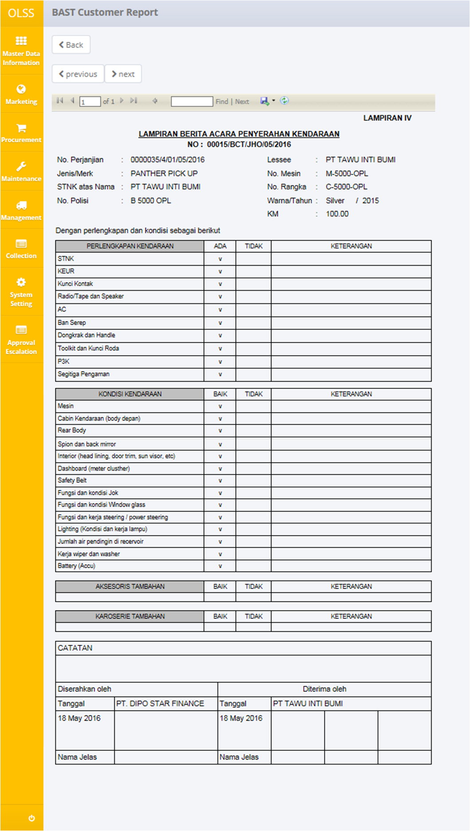

Screen 27: BAST Customer Document

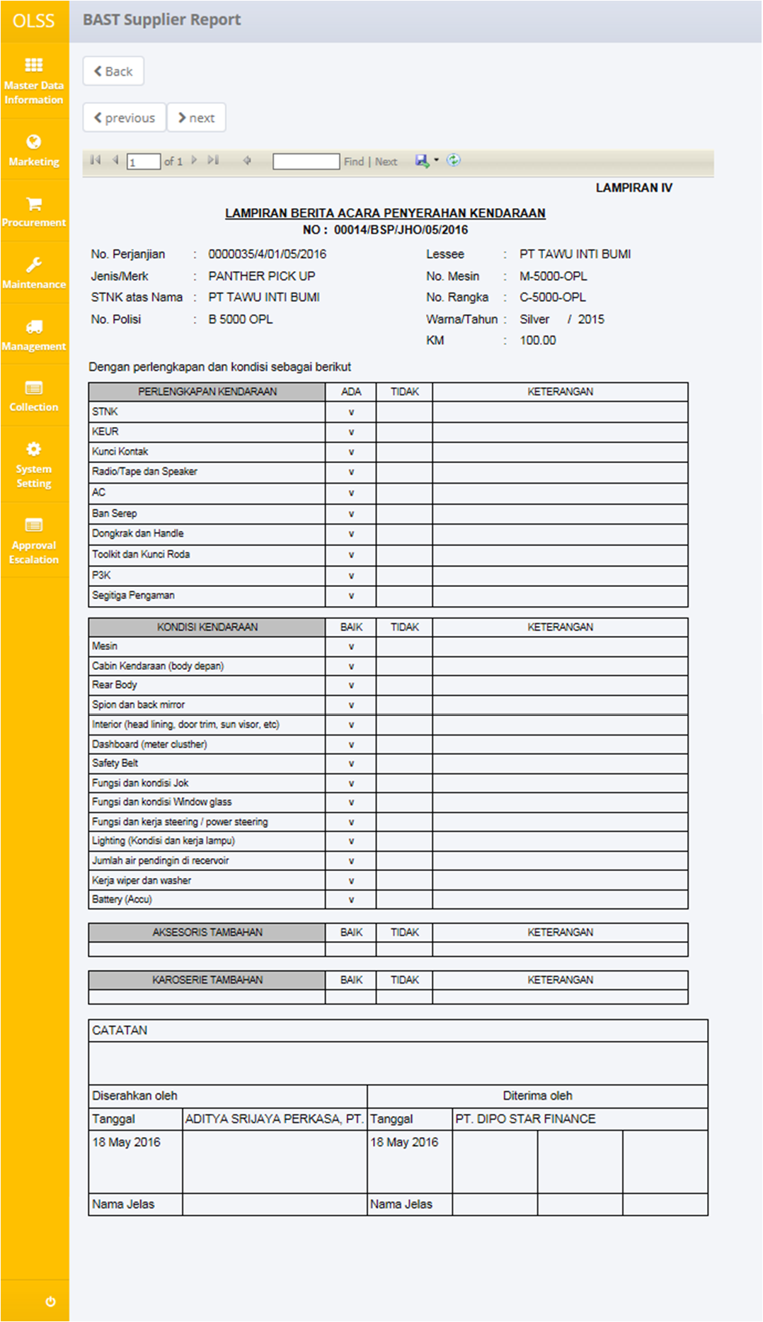

Screen 28: BAST Supplier Document

## Print BAST Report

User can print the Unit Preparation History report by navigating to tab Outstanding 45, Outstanding 20, or Outstanding 3 and then clicking the Print Report button on the bottom of the screen as shown below:

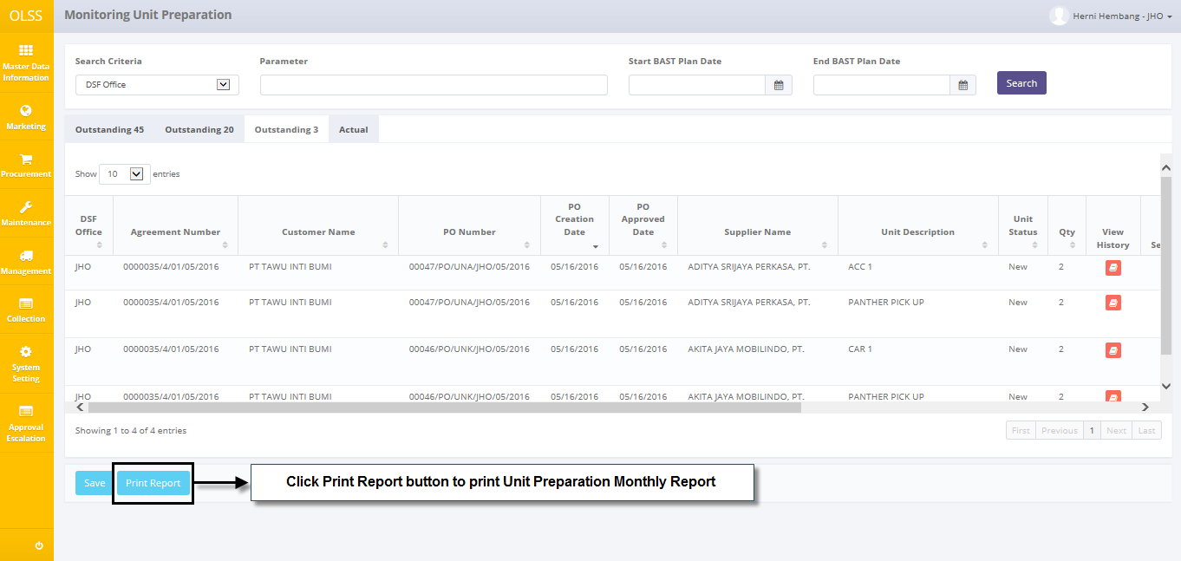

Screen 29: Navigate to Print Report Unit Preparation History

After clicking the button, system will navigate to Unit Preparation Monthly report. User can print document as hardcopy, or save document as Ms. Excel.

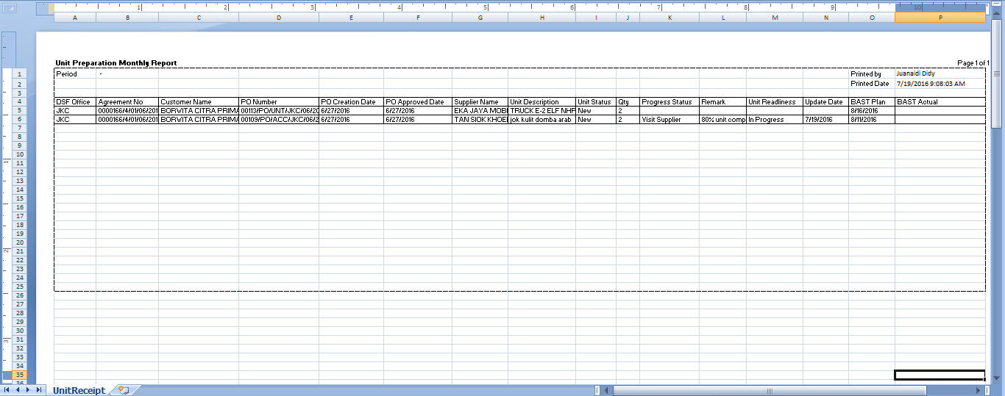

**Screen 30: Unit Preparation History Report**

User can print the Unit Receipt History report by navigating to tab Actual and then clicking the Print Report button on the bottom of the screen as shown below:

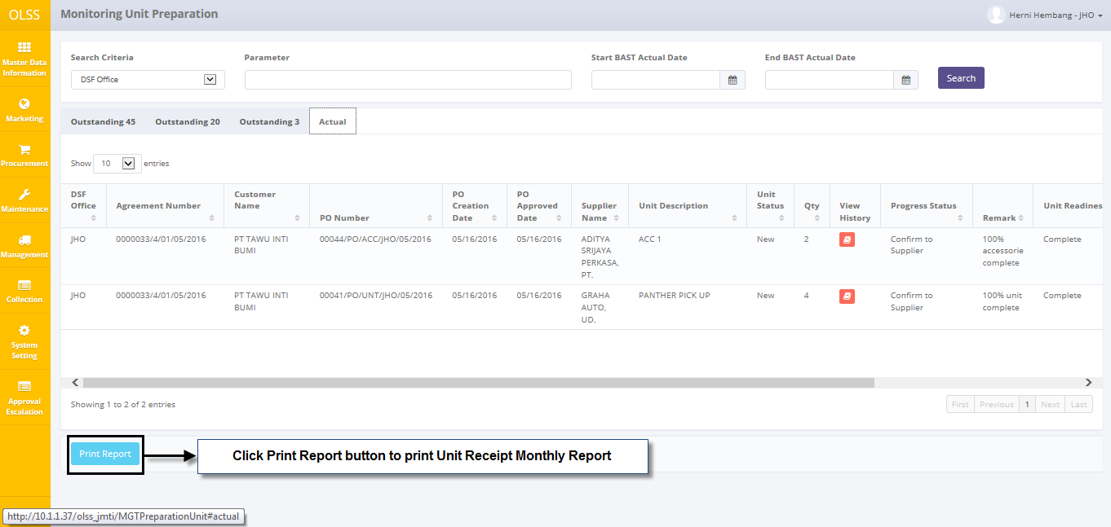

Screen 31: Navigate to Print Report Unit Receipt History

After clicking the button, system will navigate to Unit Receipt Monthly report. User can print document as hardcopy, or save document as Ms. Excel.

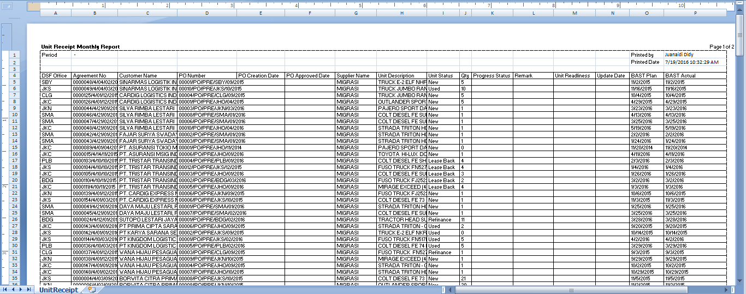

**Screen 32: Unit Receipt** **History Report**

# BAST REPLACEMENT

Generate BAST unit replacement is process related to input replacement unit request for preparing BAST replacement unit and submit BAST result out and BAST in of replacement unit and OPL unit. This process includes registering replacement unit mapping to each agreement number and OPL unit. Outputs of the process are BAST replacement unit and BAST OPL unit out and in.

**Monitoring OPL unit and Replacement Unit** screen function is to monitor availability status and location of OPL unit and replacement unit. This screen will be used by PIC asset management. This screen also provides following functions:

1. Display monitoring replacement unit by opening Monitoring Replacement screen - tab replacement unit.
2. Display monitoring OPL unit by opening Monitoring Replacement screen – tab OPL Unit.
3. Filter and sort a data that appears on the list. To do this function user can do as follows:
   * Click  to sort a record ascending or descending.
   * Filter a numbers of records by selecting.
   * Filter records by input keywords at



1. Generate BAST replacement unit document.
2. Print replacement unit report.
3. Print OPL unit report.

## Monitoring OPL unit and Replacement Unit

At the beginning, user can open Monitoring Replacement unit and OPL unit by clicking the Monitoring Replacement unit and OPL unit button on Unit Management Menu.

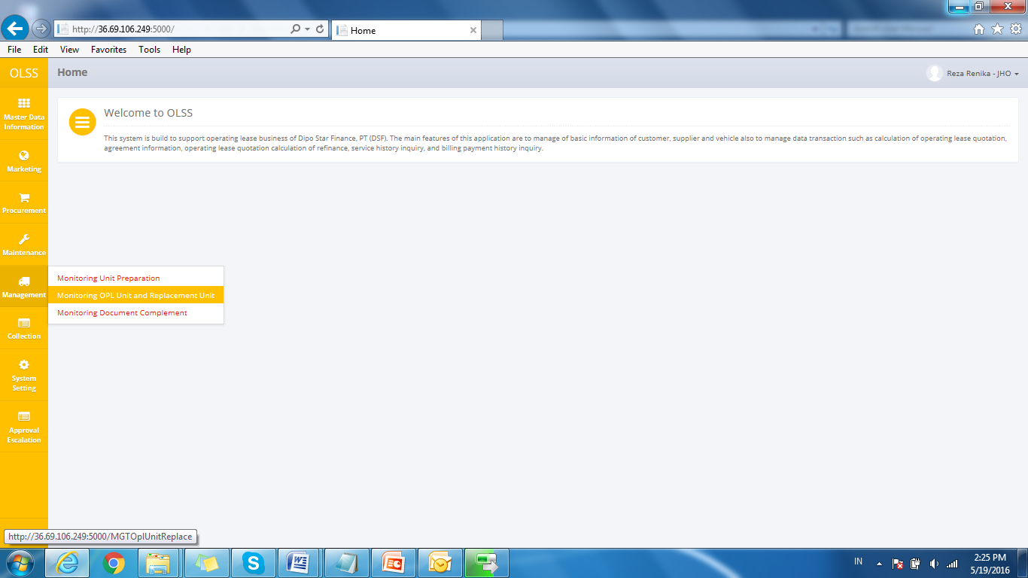

**Screen 33: Monitoring OPL Unit and Replacement Unit Menu**

Once **Monitoring OPL unit and Replacement Unit** screen is opened, there are 2 tabs showed: Replacement unit tab, and OPL unit tab.

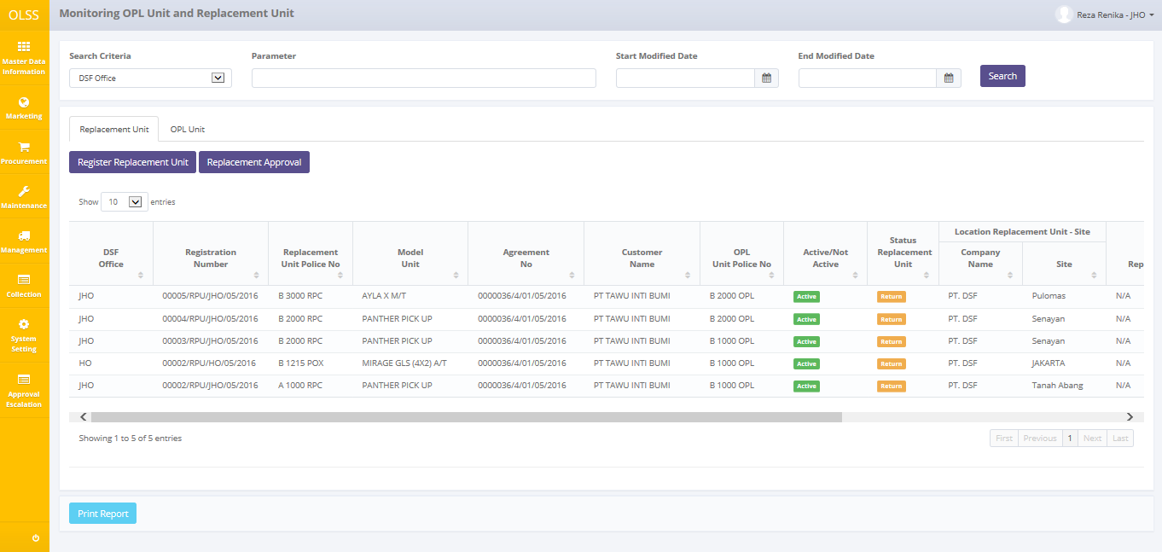

**Screen 34: Screen Monitoring Replacement Unit**

Each tab gives different information. On replacement unit tab there is showed list of replacement unit, document status, replacement unit status, replacement unit location, replacement type, and usage period. Document status divided into 2 statuses, which is active and not active.

* Active means the replacement unit still support to the unit OPL
* Not active means the replacement unit not support to the unit OPL

Replacement unit also have status to notified replacement unit location, which is customer, return, and workshop.

* Customer means the replacement unit is used by customer.
* Return, means the replacement unit has been returned by customer.
* Workshop means the replacement unit is on the workshop.
* Insurance means the replacement unit is on the insurance.

**Monitoring OPL unit and Replacement unit** will display total of 8 buttons, described as follows:

* Register replacement unit, click to register replacement for requested unit.
* Replacement approval, click to manage approval for special case replacement type.
* Create BAST replacement, click to create BAST replacement. Only enabled if replacement unit status is Return.
* Edit BAST replacement, click to edit BAST replacement. Only enabled if BAST already created and saved as draft.
* View BAST detail, click to view information related with selected agreement number.
* View Replacement Unit Usage History, click to view BAST progress history related with agreement number.
* Print BAST replacement form.
* Print BAST replacement report.

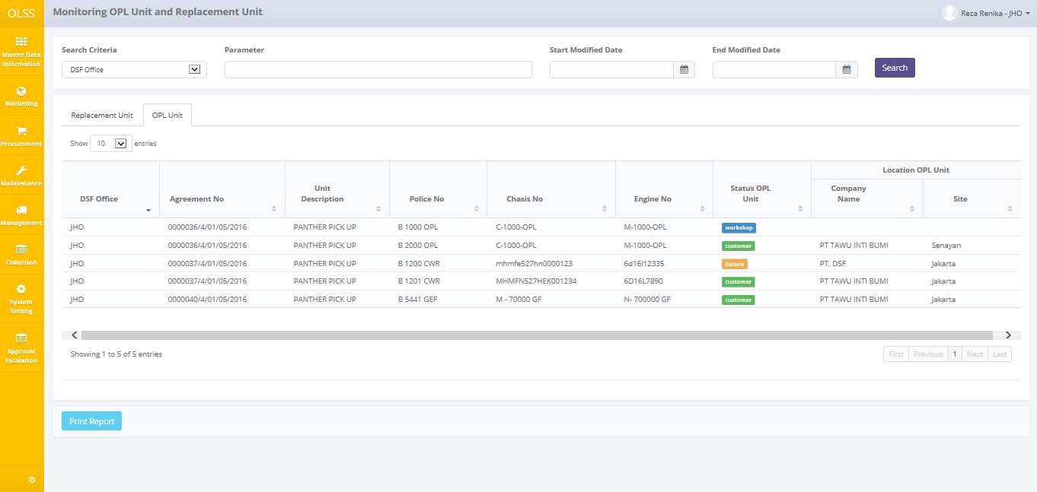

**Screen 35: Screen Monitoring OPL Unit**

If user clicks on tab OPL unit, system will display different information. On OPL unit tab, there is information about list of OPL unit, location OPL unit, and OPL unit status. Only one button is showed here, that is Print Report button to print BAST OPL unit history report.

## View History Replacement Unit Usage

History replacement unit usage holds information for replacement usage progress. To check replacement unit usage history, click  button on Monitoring Replacement unit and OPL unit screen.

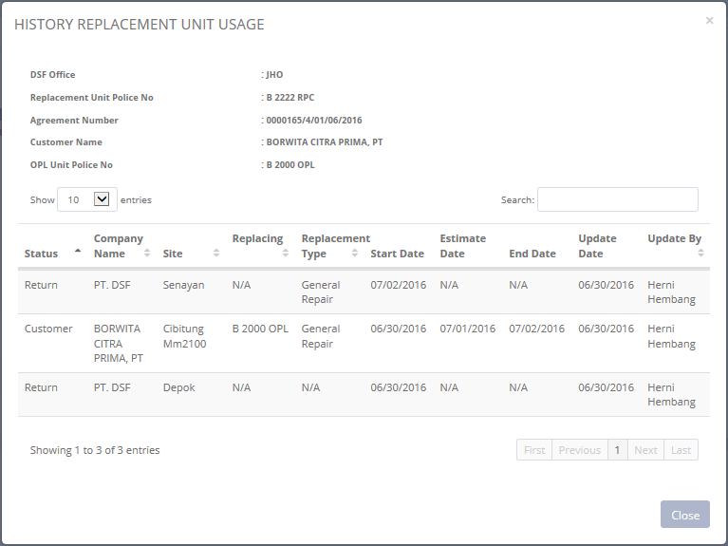

**Screen 36: Screen History Replacement Unit Usage**

System showed History Replacement Unit Usage pop-up. There is one button on pop-up, it is Close button. Click button **Close** to finish viewing the detail and back to **Monitoring OPL unit and Replacement Unit** screen.

## Print BAST replacement unit report

User can print the list of replacement unit report by navigating to **Monitoring Replacement unit and OPL unit – Replacement unit** **tab**, and then clicking the **Print Report** button on the bottom of the screen as shown below:

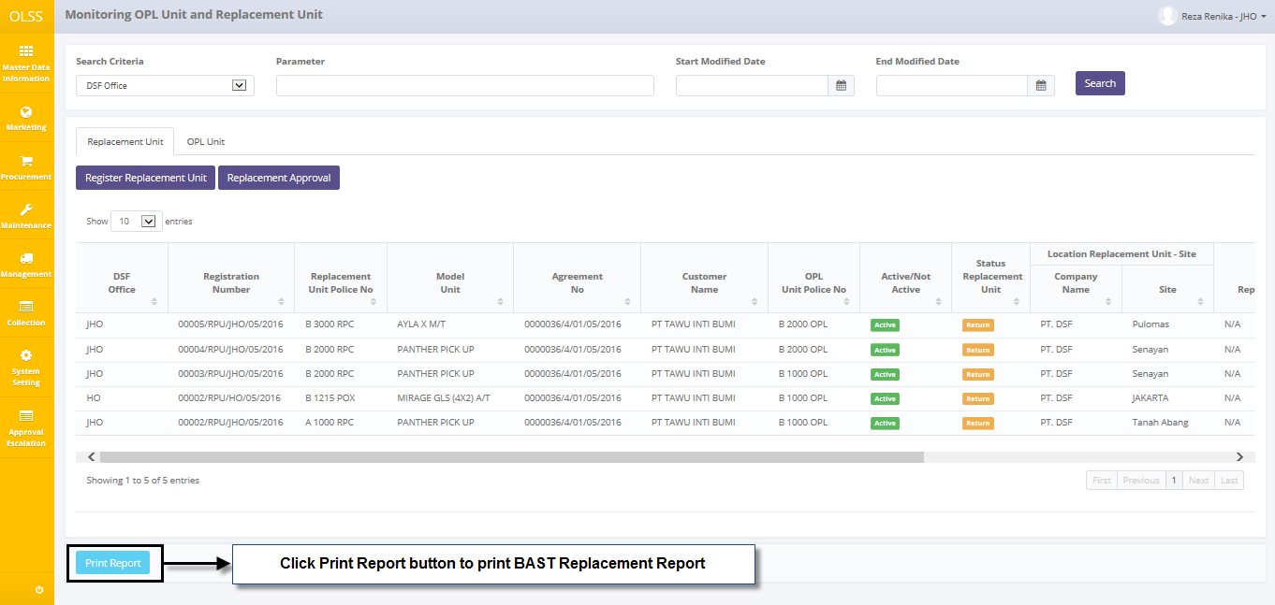

Screen 37: Navigate to Print Replacement BAST Unit report

After clicking the button, system will navigate to Replacement Unit report with format excel. User can print document as hardcopy, or save document as Ms. Excel.

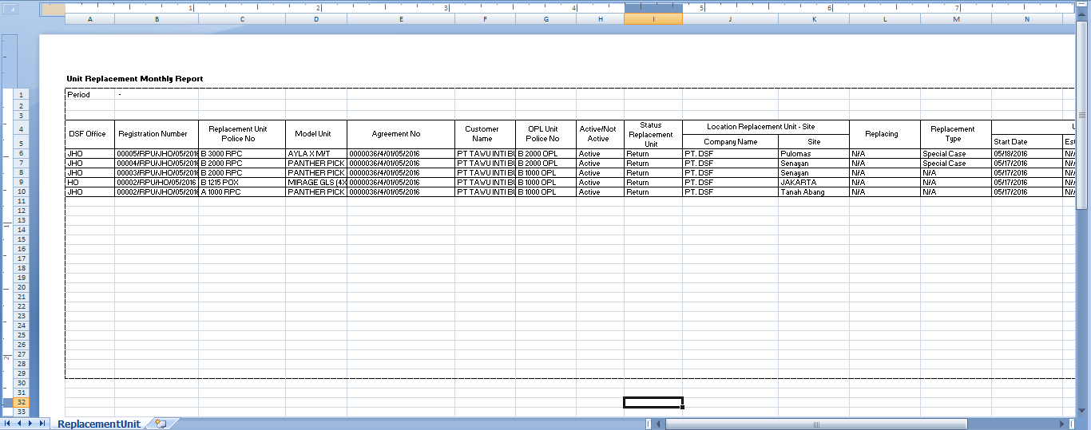

Screen 38: Print Replacement BAST Unit report

## Print BAST OPL unit report

User can print the list of OPL unit report by navigating to **Monitoring Replacement unit and OPL unit – OPL unit tab**, and then clicking the **Print Report** button on the bottom of the screen as shown below:

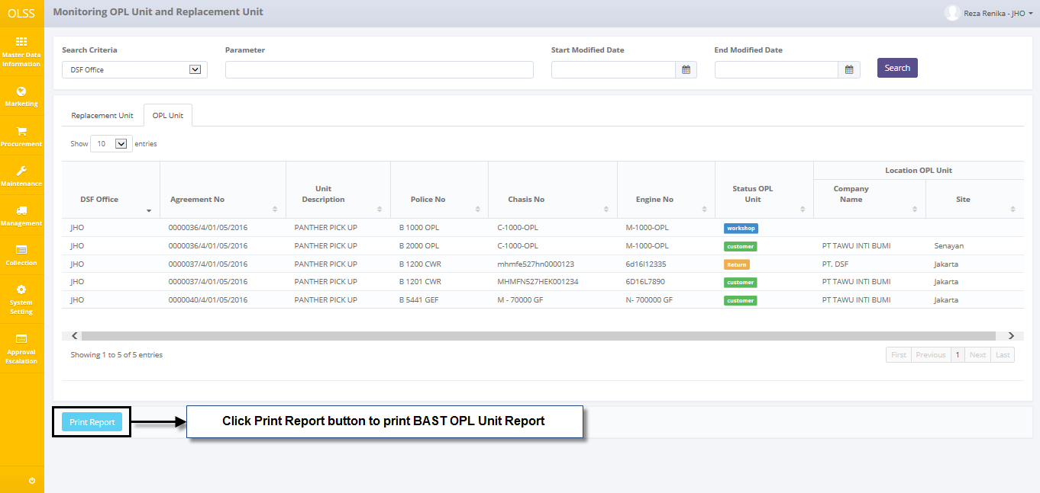

Screen 39: Navigate to Print OPL Unit report

After clicking the button, system will navigate to OPL unit report. User can print document as hardcopy, or save document as Ms. Excel.

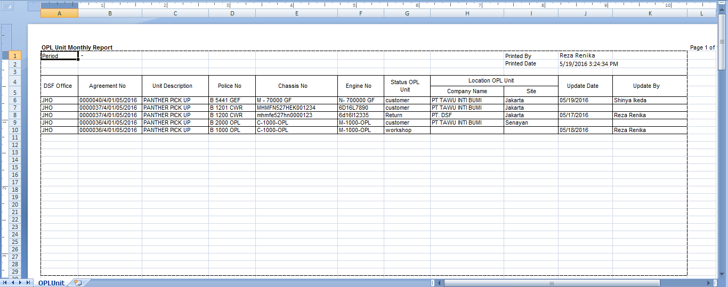

Screen 40: Print OPL Unit report

## Register Replacement Unit

To register replacement unit, first navigate to **Monitoring** **OPL unit and Replacement Unit** – R**eplacement Unit Tab**. Then click **Register Replacement Unit** button on top of the screen.

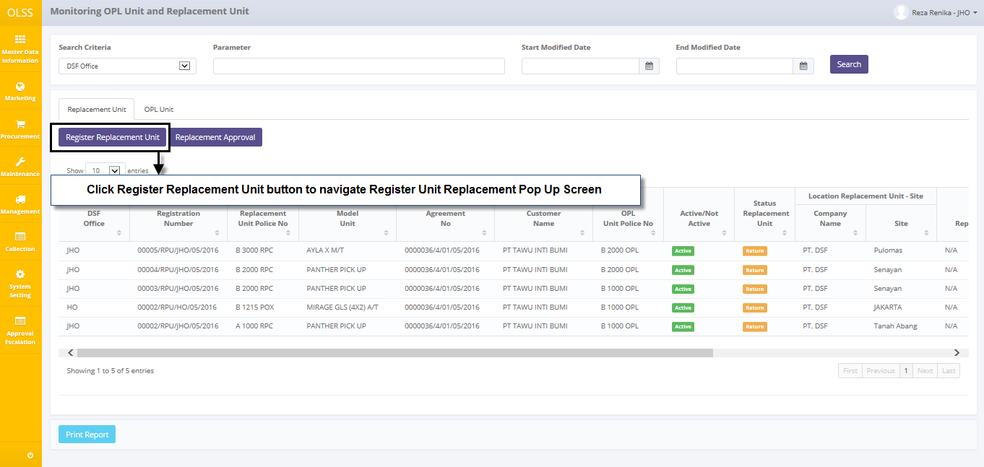

Screen 41: Navigate to Register Replacement Unit

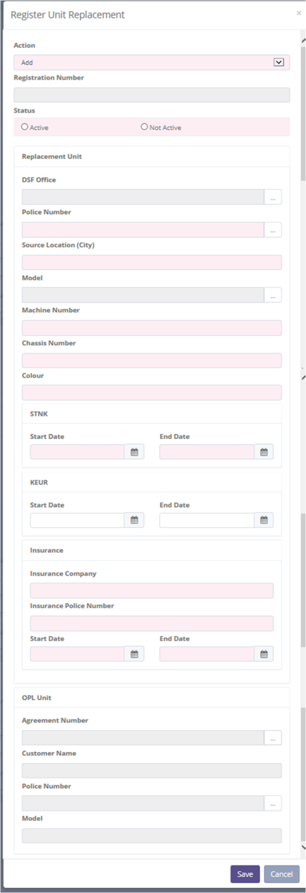

Screen 42: Register Replacement Unit Pop Up Screen

Once the Register Replacement Unit screen is opened, there are 2 buttons that will be displayed on the screen as follows:

* 1. , click to register new replacement unit.
  2. , click to go back to previous screen; Monitoring OPL Unit and Replacement Unit.

Input data as following:

* 1. Action: select Add.
  2. Registration number: automatically generate new registration number upon saving.

1. Status: select Active or Not Active.
2. Replacement unit

* DSF office: select DSF office on pop-up dialog.
* Police number: select police number on pop-up dialog
* Source location (city): input locations.
* Model: select model name list on pop-up dialog
* Machine number: input machine number.
* Chassis number: input chassis number.
* Color: input color.

1. STNK start date: select date. Can’t be more than STNK end date.
2. STNK end date: select date. Can’t be less than STNK start date.
3. KEUR start date: select date. Can’t be more than KEUR end date. If leave blank, system will ask confirmation.
4. KEUR end date: select date. Can’t be less than KEUR start date. If leave blank, system will ask confirmation.
5. Insurance

* Insurance company: input insurance company name
* Insurance police number: input insurance policy number
* Insurance start date: select date. Can’t be more than insurance end date.
* Insurance end date: select date. Can’t be less than insurance start date.

1. OPL unit

* Agreement number: select agreement number on pop-up dialog
* Police number: select OPL unit police number on pop-up dialog

If data already input on the screen, user can save a data on the system by clicking **Save button**. System will show an confirmation and notify if the data have been successfully saved or not.

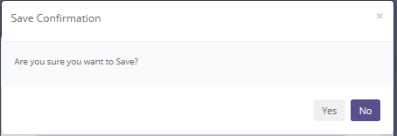

**Screen 43: Confirmation Pop Up after Save**



**Screen 44: Success Notification after Save**

## Create BAST replacement unit and OPL unit

If user wants to create new BAST Replacement unit or BAST OPL Unit, please follow procedures shown below:

To start creating BAST, please input following fields with necessary information:

1. Click **create BAST** button on selected agreement.

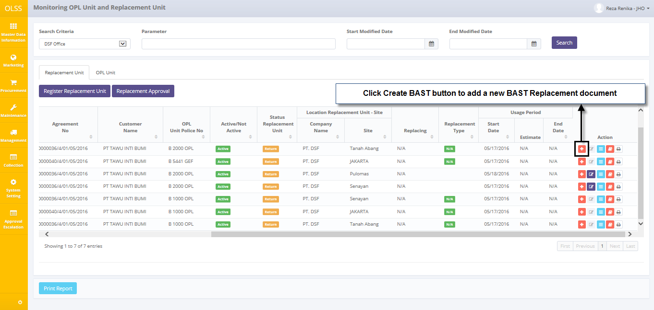

**Screen 45: Navigate to Create BAST**

1. System will display create BAST replacement selection.

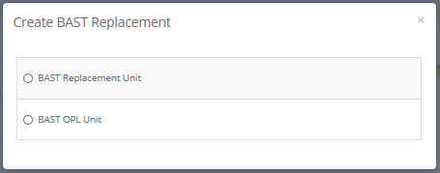

**Screen 46: Option Create BAST Replacement Pop Up**

1. Select BAST replacement unit or BAST OPL unit, click next.

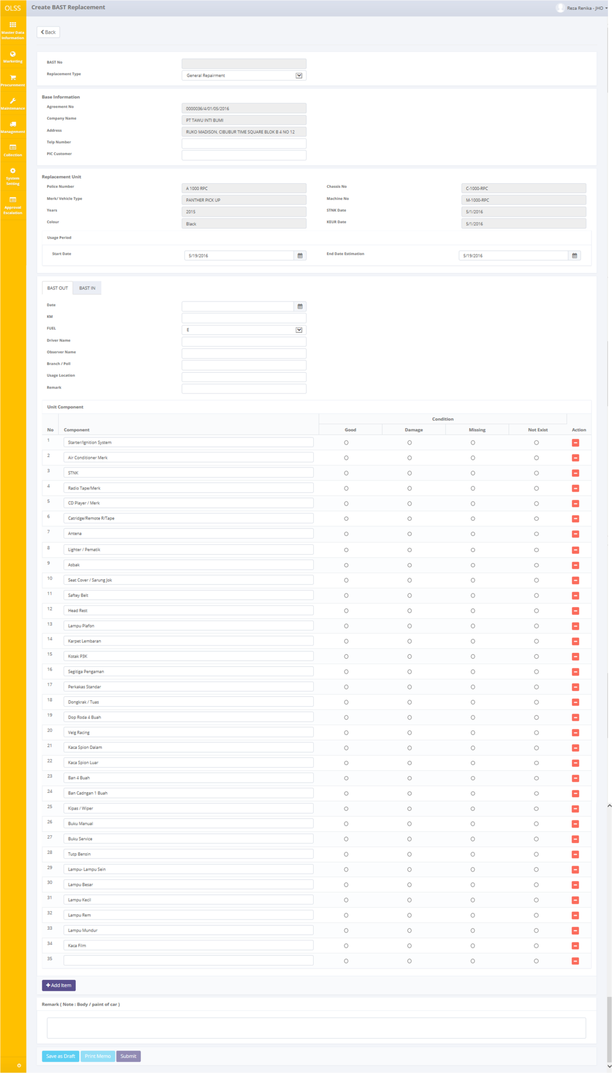

**Screen 47: Screen Create BAST Replacement**

Once Create BAST screen opened, there are 2 buttons displayed:

1. Back: click the button to go to previous screen: unit preparation monitoring.
2. Save as Draft: click the button to save document temporary as draft.
3. Print memo: click to print memo remarks for special case replacement type.
4. Submit: click to submit document. Can no longer be edited.

To start creating BAST Replacement, input information as following:

* 1. BAST No: automatically generated after saving.
  2. Replacement Type: select one from below,
* General Repairment
* Insurance claim
* Special case
  1. Remarks for special case: only enabled if replacement type is special case. User input note for request approval replacement unit to authorize person
  2. Base information
* Agreement no: automatically displayed selected agreement number
* Company name: automatically displayed company name based on selected agreement number
* Address: automatically displayed address based on selected agreement number
* Telp number: input telp number
* PIC customer: input PIC customer

1. Replacement unit / OPL Unit: automatically displayed data based on selected agreement number.
2. Usage period start date: select date. Can’t be more than usage end date.
3. Usage period end date estimation: select date. Can’t be less than usage start date.
4. Tab BAST OUT / BAST IN:

* Date: select BAST out/ BAST in date
* KM: input how many KM unit has been driven
* Fuel: select how much fuel
* Driver name: input driver name
* Observer name: input observer name
* Branch/pull: input branch / pull
* Usage location: input location
* Remark: input remarks.

1. Unit component

* Click **add item** to input row for more component, or click **remove** **item** to delete row.
* Condition: select component current condition. Good, damage, missing, or not exists

1. Remark (note: body/paint of car)

If data already inputted on the screen, user can save a data on the system by clicking **Save as Draft** button. After clicking **Save as Draft**, confirmation pop-up dialog will show up. Click yes to save document.

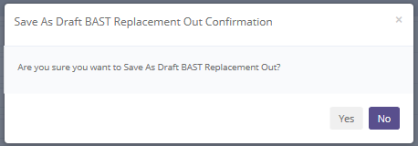

**Screen 48: Pop Up Confirmation after Save as Draft**

System will notified if it success or failed to Save changes or Submit a data.



Screen 49: Success notification after Save as Draft

## Edit BAST replacement unit and OPL unit

To edit BAST document, navigate to the **Monitoring Replacement Unit and OPL unit** and click Edit button on the right side of selected agreement. Edit button only enabled if BAST already created and saved as draft.

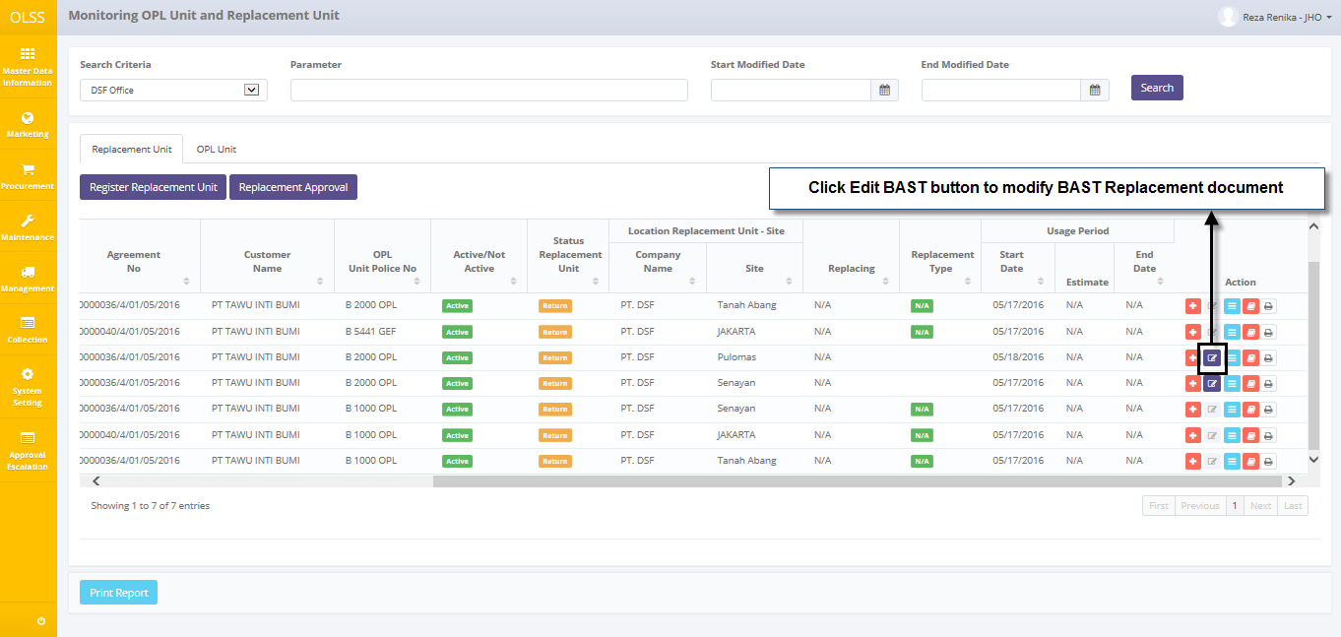

Screen 50: Navigate to Edit BAST

Select Replacement Unit or OPL unit, and then select agreement number. Click next to continue.

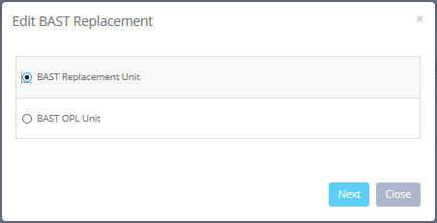

**Screen 51: Edit BAST Replacement Pop Up**

The screen below is shown after the Edit button is clicked.

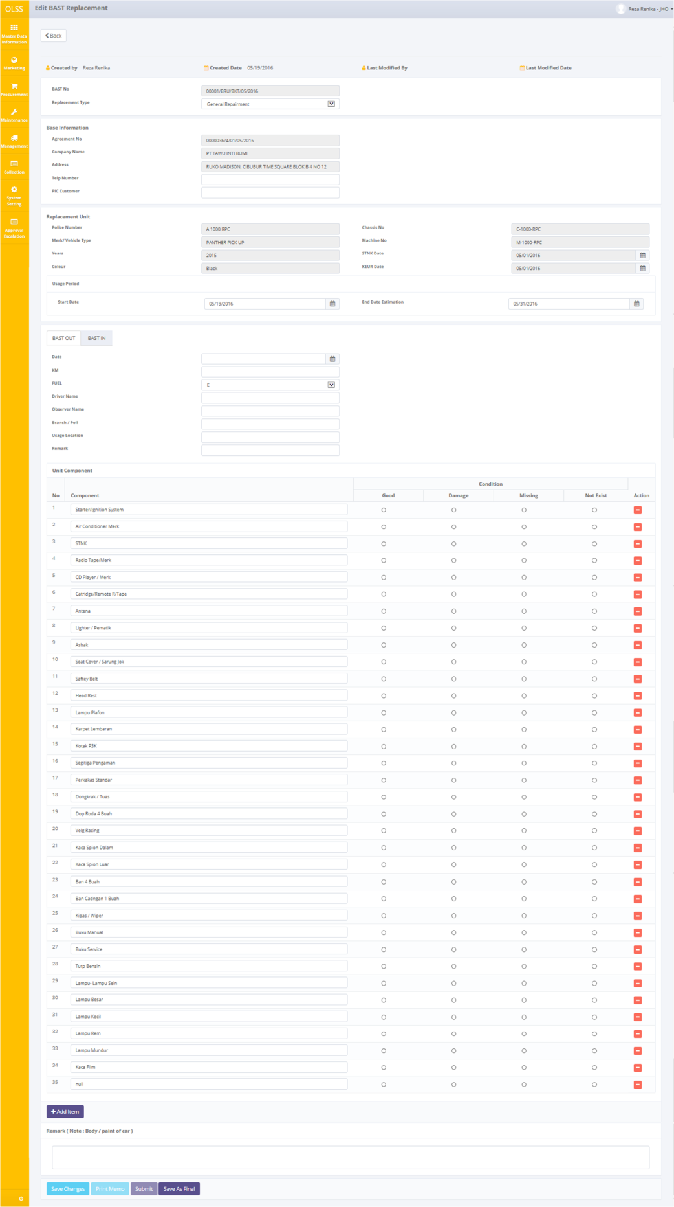

Screen 52: Screen of Edit BAST

There are five buttons that will be displayed on the screen as follows:

1. Back, on the top-left corner of the screen.
2. Save Changes, on the bottom-left corner of the screen.
3. Print Memo, click to print memo remarks for special case replacement type.
4. Submit, on the bottom-left corner of the screen.
5. Save as Final, on the bottom-left corner of the screen. Save as Final to confirm BAST document.

If data already changed on the screen, user can save a data on the system by clicking **Save Changes** button. After clicking **Save Changes** button, confirmation pop-up dialog will show up. Click yes to save document.

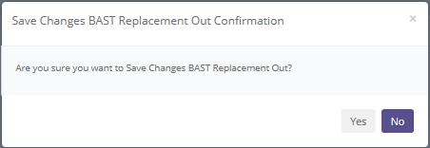

**Screen 53: Confirmation Pop Up after Save Changes**

System will notified if it success or failed to save changes or save as final a data.



Screen 54: Success notification after Save Changes

## View BAST replacement unit and OPL unit

To view the records, you can select a record from the **Monitoring OPL unit and Replacement Unit** page. Navigate to tab Replacement, and then click the view details button, on selected agreement.

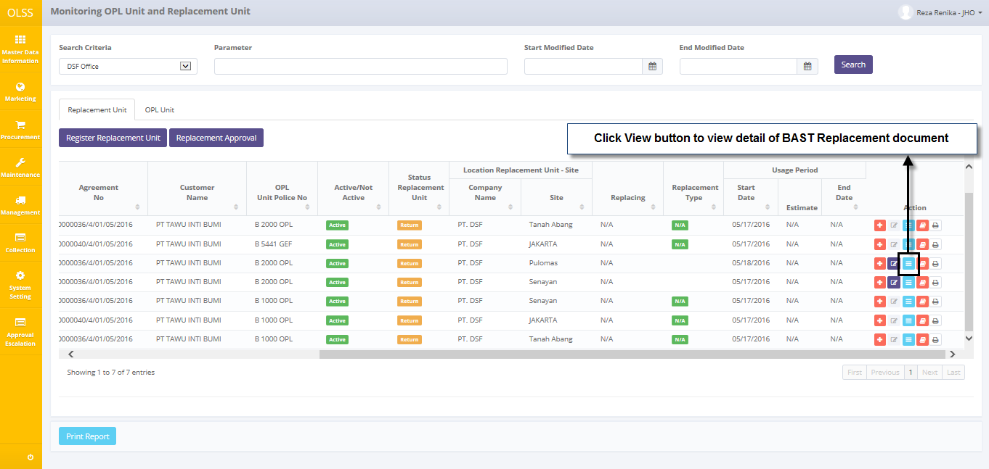

Screen 55: Navigate to View Detail BAST

Select Replacement unit or OPL unit, and select BAST number. Click Next to continue.

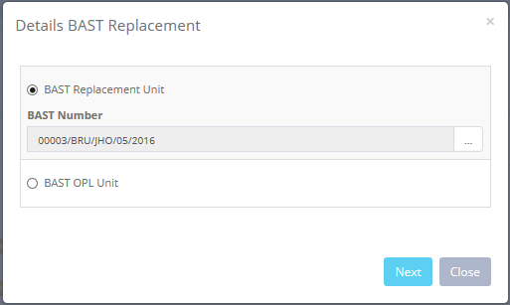

Screen 56: Detail BAST Replacement Pop Up

Screen will show View BAST screen shown below:

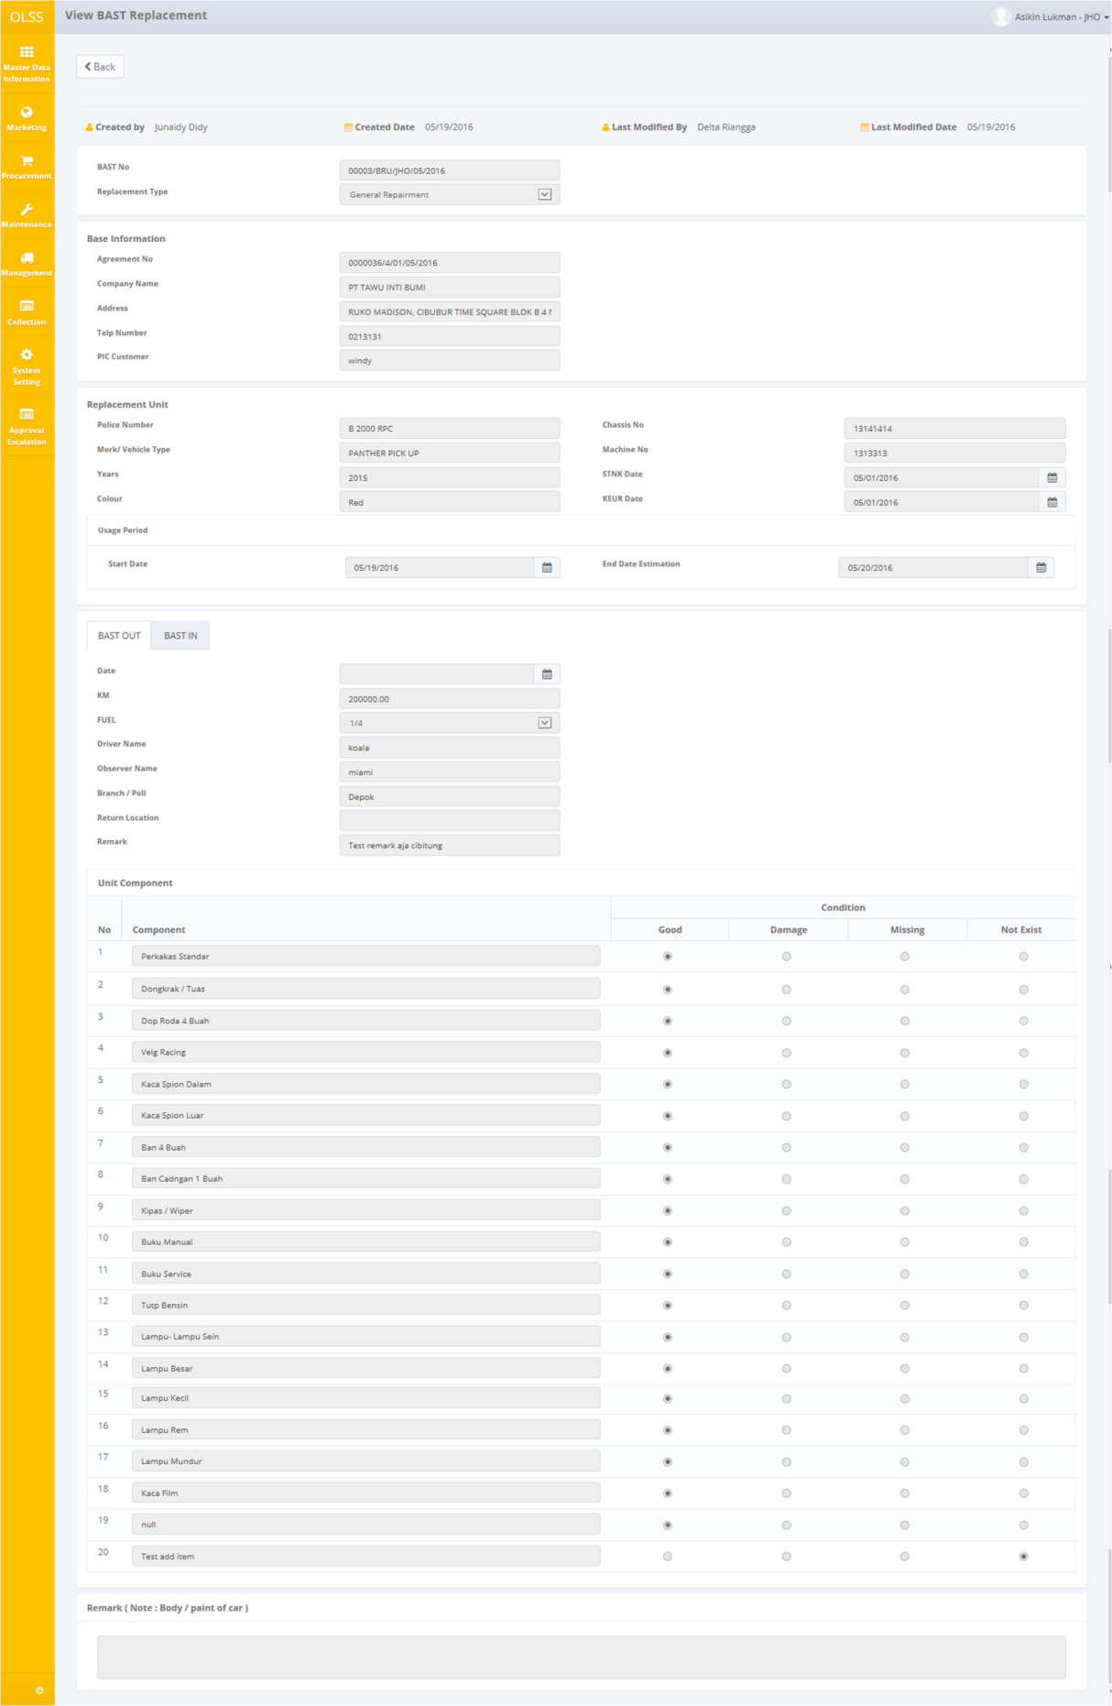

Screen 57: Screen View Detail BAST Replacement

Here you can see the detail information related with BAST replacement or BAST OPL. User can check the records but the records cannot be clicked or edited. Click  on top of the screen to go back to previous screen.

## Print BAST replacement form

User can print the BAST Replacement form by navigating to Monitoring Replacement unit and OPL unit – Replacement unit tab, and then clicking the Print replacement button on selected agreement number as shown below:

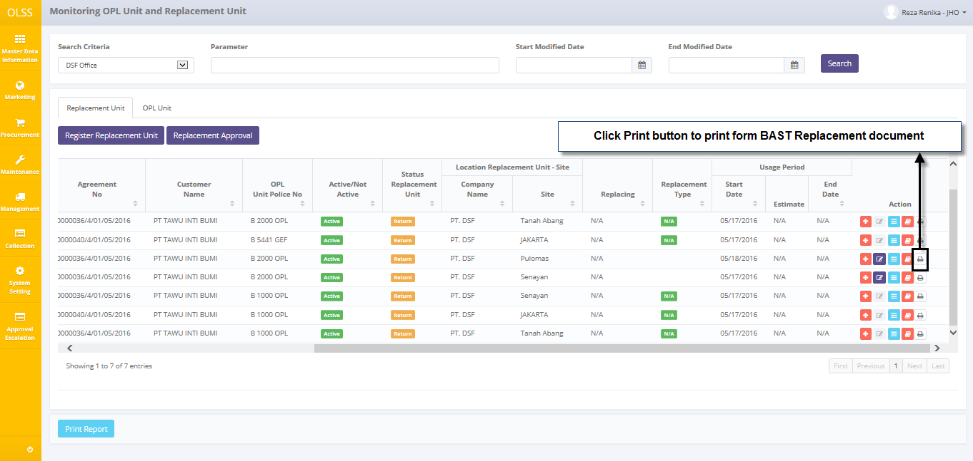

Screen 58: Navigate to Print Form BAST

After clicking the button, system will navigate to BAST replacement unit form print preview. User can print document as hardcopy, or save document as PDF or Ms. Excel.

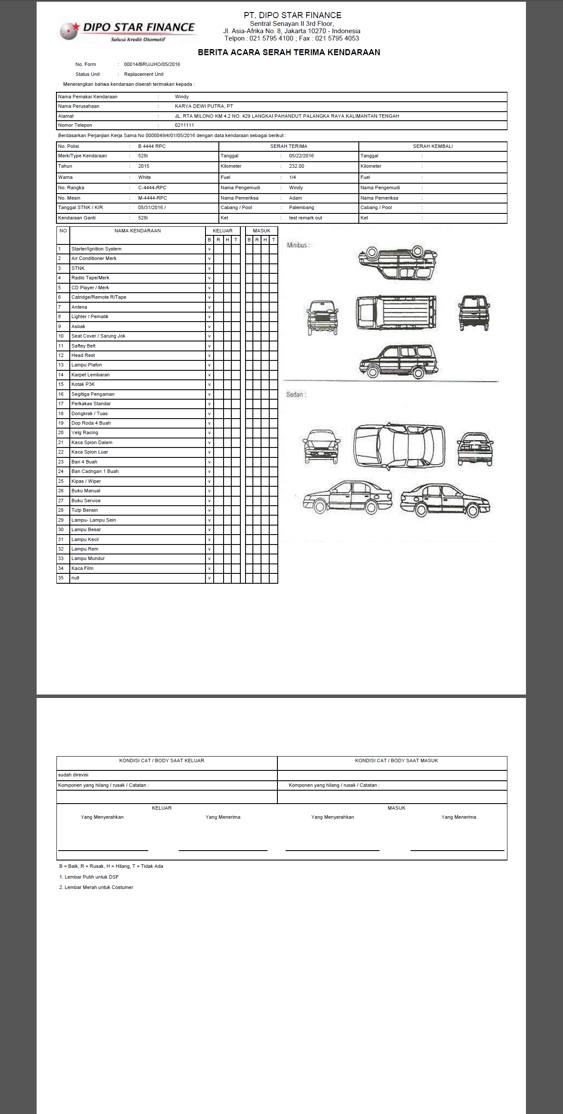

Screen 59: BAST Replacement Form

## Print memo replacement report (Special Case)

User can print the memo replacement form by navigating to Monitoring Replacement unit and OPL unit – Replacement unit tab, and then click Edit button on selected agreement. After Edit BAST Replacement screen is open, click Print memo on the bottom of the screen as shown below:

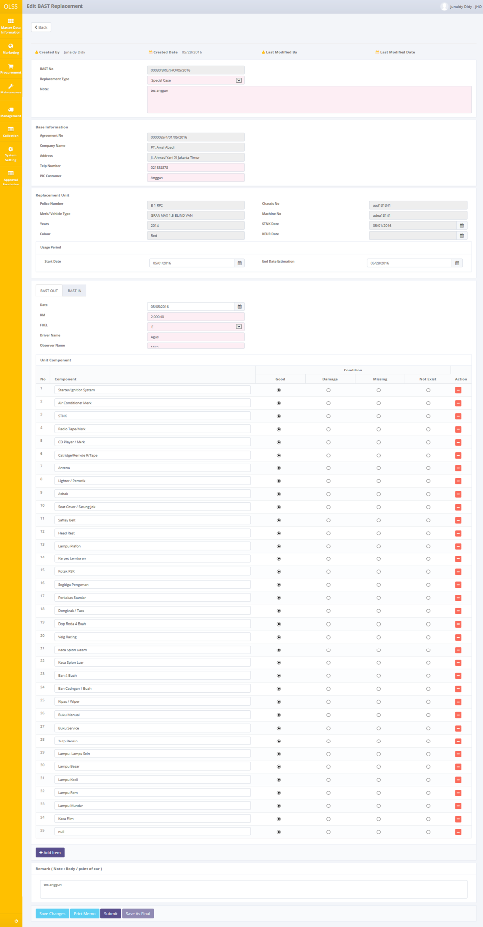

Screen 60: Screen Edit BAST Replacement

After clicking the button, system will navigate to memo replacement unit form print preview. User can print document as hardcopy, or save document as PDF or Ms. Excel.

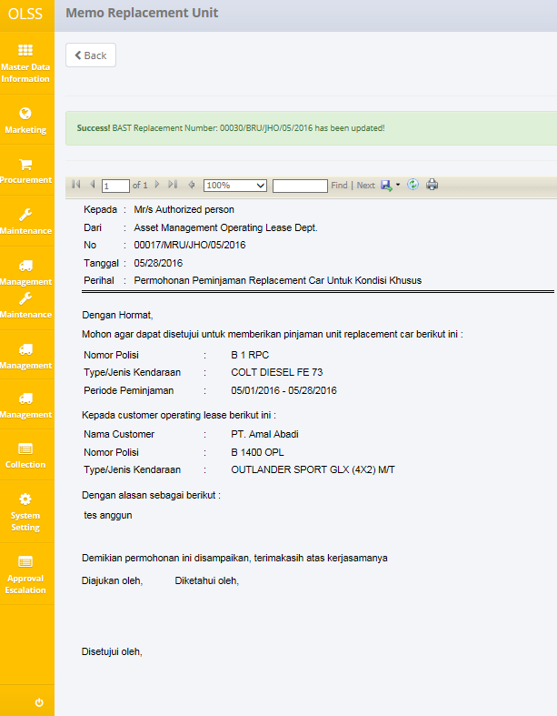

Screen 61: Print Preview Memo Replacement Unit

# BAST REPLACEMENT APPROVAL

Replacement unit approval is process related to approve or reject special case replacement unit request by authorized person. Will be used by DSF authorized person to approve or reject the submitted special case replacement unit request.

Approval level :

1. Proposed : ASSET MANAGEMENT-PIC Control Stock & Admin
2. Checked : HOD OPL
3. Approved : EXECUTIVE GENERAL MANAGER RESEARCH & DEVELOPMENT/MKT DIRECTOR/REGIONAL DIRECTOR/DIRECTOR FOR COLLECTION, LEGAL & HUMAN RESOURCES/EXECUTIVE GENERAL MANAGER FINANCE/OPERATION DIRECTOR/VICE PRESIDENT DIRECTOR/PRESIDENT DIRECTOR

The screen will monitor list of replacement unit approval which replacement type is special case. This page will also feature:

1. Display list of special case request replacement unit with status document of each request.
2. Approve special case replacement unit request.
3. Reject special case replacement unit request.

To enter list of Unit Replacement Approval, navigate to Monitoring Replacement Unit and OPL Unit – Replacement unit Tab. Click Replacement Unit Approval button on top of the screen.

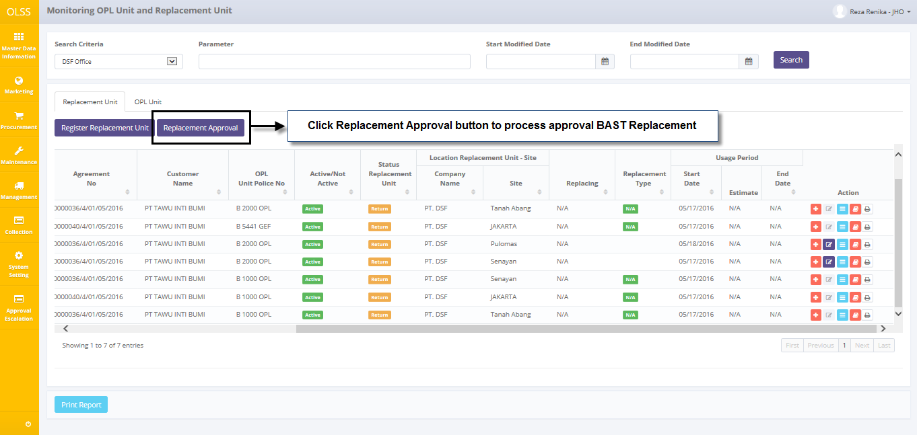

Screen 62: Navigate to Enter List of Unit Replacement Approval

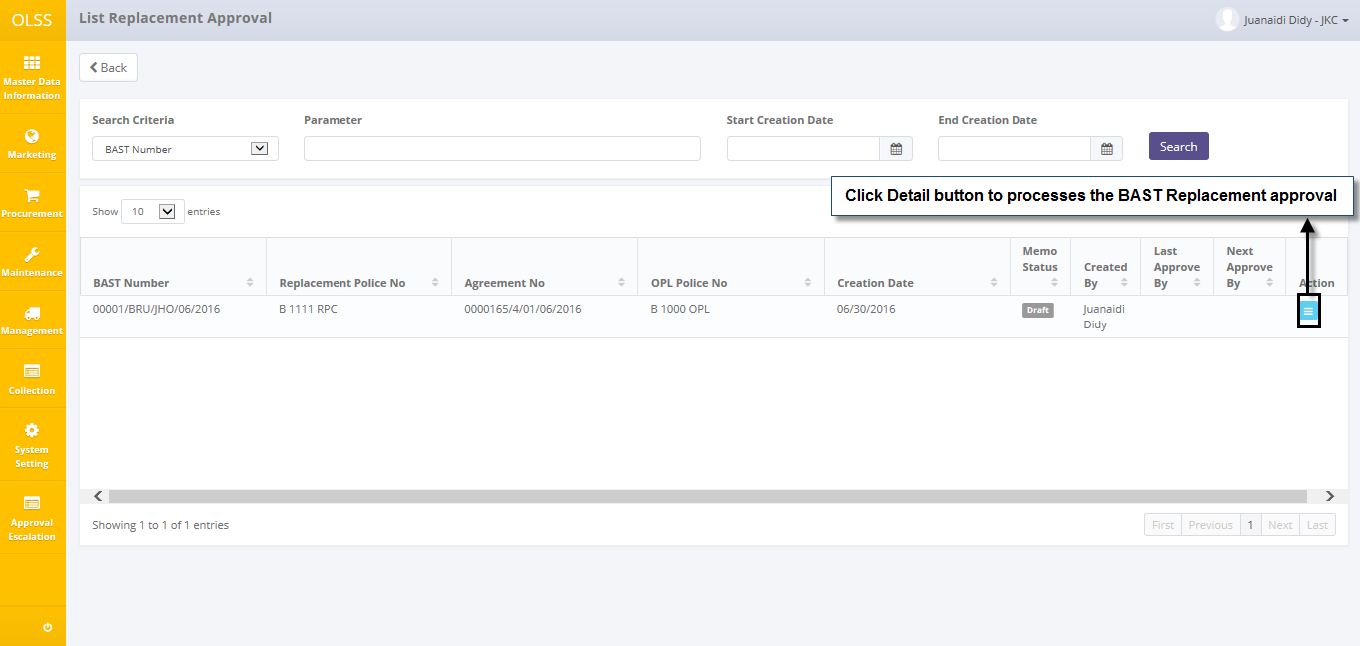

Screen 63: Navigate to Enter Special Case Approval Screen

Once the view detail is open, user can see information related with BAST replacement unit with special case. There are two buttons available on the bottom of the screen, which are:

1. Approve, to give a sign that user has approved the document. Document status will change to approved.
2. Reject, to give a sign that document is rejected DSF authorization person. Document status will change to rejected.

If BAST Replacement will be approved or rejected, user has to fill remarks with reason. Then click the button on the bottom of the screen.

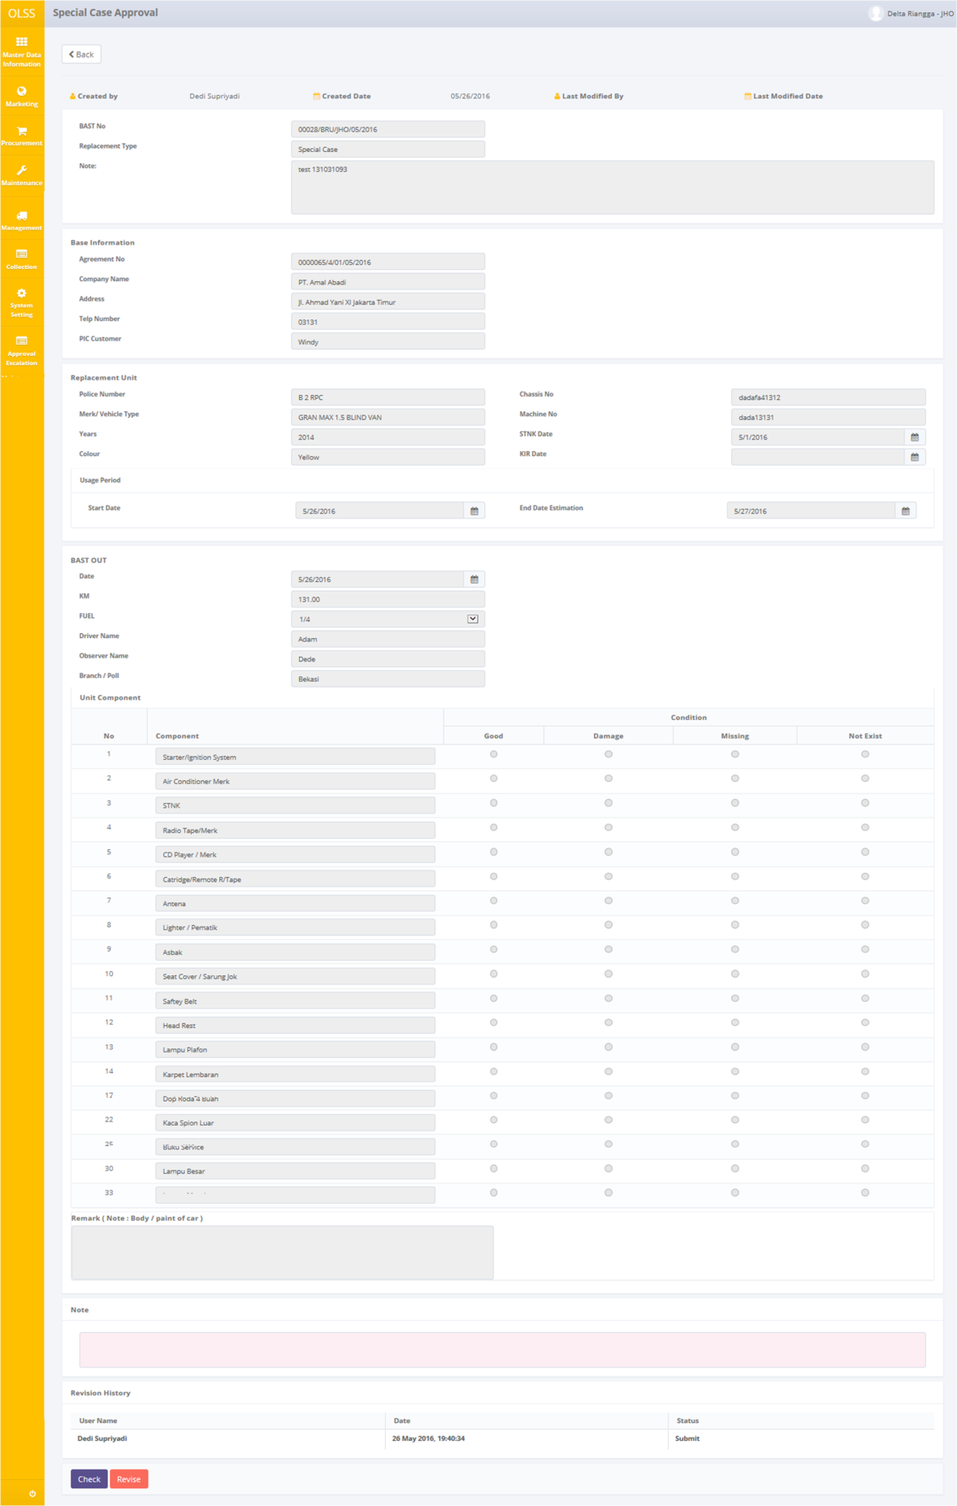

**Screen 64: Screen Special Case Approval (Check and Revise)**

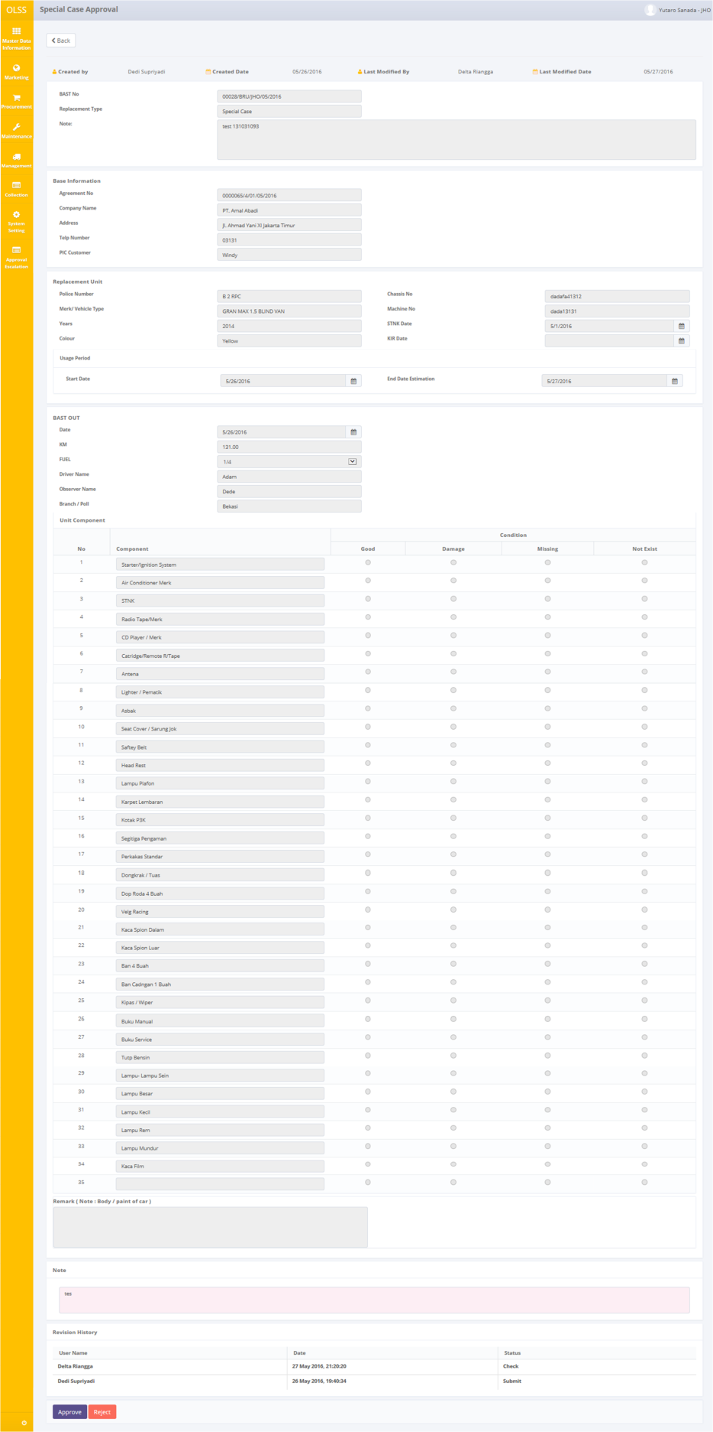

**Screen 65: Screen Special Case Approval (Approve and Reject)**

After clicking Approve or Reject button, system will notified if it success of failed to approve or reject data.



**Screen 66: Success Notification after Check**



**Screen 67: Success Notification after Approve**

# MONITORING AND PRINT DOCUMENT COMPLEMENT UNIT

Monitoring and print document complement unit is process related to view and update expired date of STNK and KEUR document, and also update expired insurance policy.

## View list of expired and pending document

To check list of expired and pending document, navigate to unit management menu and click Monitoring Document. System will show Monitoring Document screen that consist of Expired document and pending document for specific agreement that already recorded in the system.

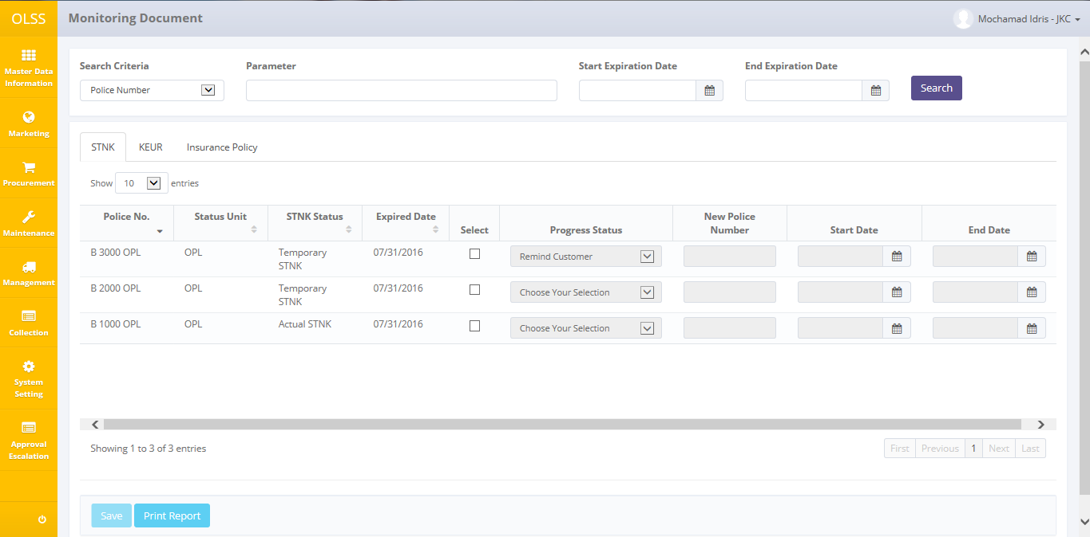

**Screen 68: Monitoring Document Screen - STNK**

There are three tabs in total on top of the screen, which are: STNK, KEUR, and Insurance Policy. Each holds different document based on the type of document.

On the bottom of the screen there are two buttons:

* 1. Save, to save changes for selected documents.
  2. Print report, to print Complement Document Form.

## Update progress expired document

To start updating the Monitoring Document, user has to check on the checklist field for document that wants to be updated. For Tab STNK, users have to select Progress Status available.

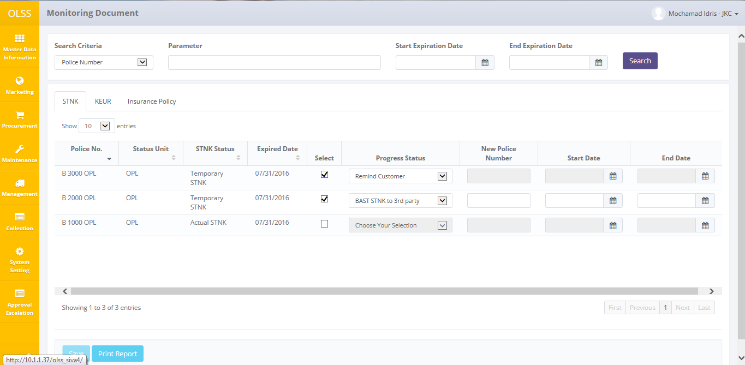

**Screen 69: Update Progress Document**

If user chooses BAST STNK to 3rd party in Progress Status field, then users have to input New Police Number, Start date, and End date. After the information has been inputted, user can select on more than one document at once. Then click **Save** button to update document in batch. The screen will stay in Monitoring Document screen and there will be success notification on top of the screen.

## Print monitoring unit report

User can print the monitoring document report by navigating to Monitoring Document screen, and then click Print Report on the bottom of the screen as shown below:

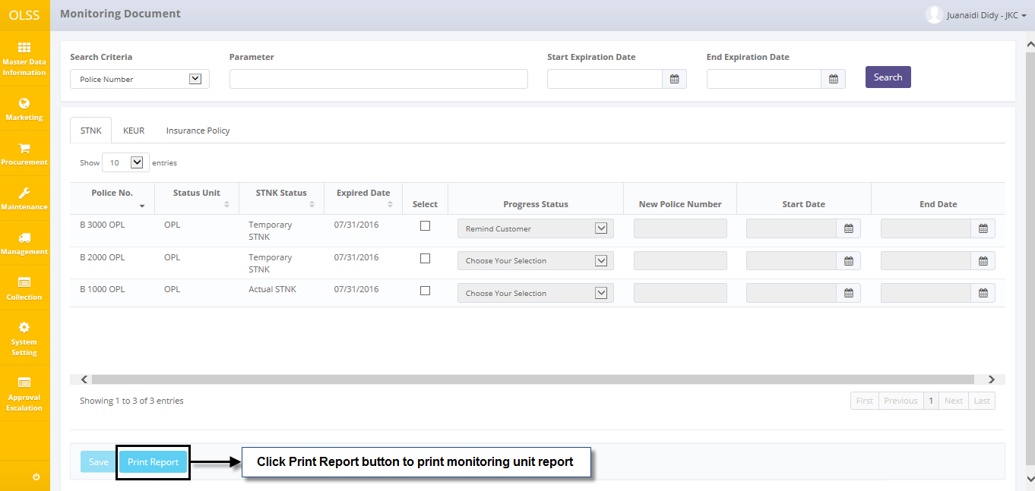

Screen 70: Navigate to Print Report Monitoring Unit

After clicking the button, system will navigate to Monitoring Document Report print preview. User can print document as hardcopy, or save document as PDF or Ms. Excel.

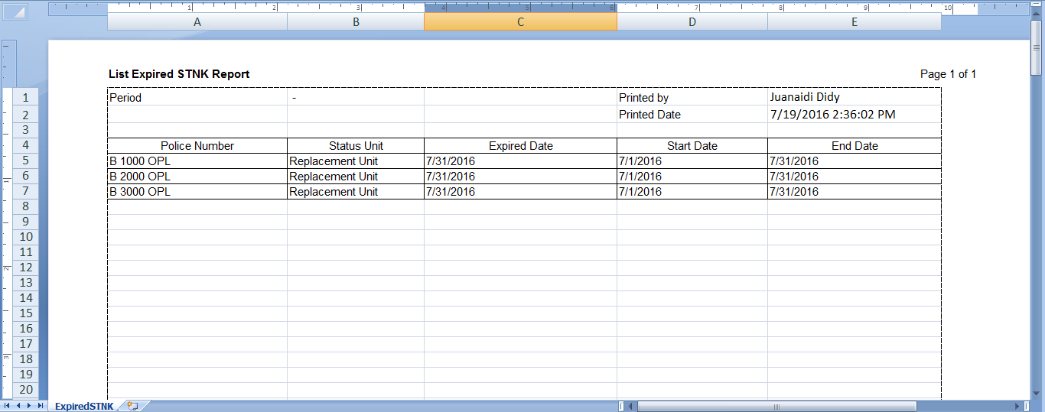

**Screen 71: List Expired STNK Report**